

**MIT Art, Design and Technology University**

**MIT School of Computing, Pune**

**Department of Information Technology**

|  |
| --- |
| **Lab Manual** |

# **Practical - Web Programming**

# **Class - S.Y. (SEM-II), DA**

# **Batch - DA-I**

# **Name of the Student**

# **Mr. Manthan Pravin Sasane**

**A.Y. 2024 – 2025 (SEM-II)**

|  |  |  |  |  |  |
| --- | --- | --- | --- | --- | --- |
| **Web Programming**  **SEMESTER – IV** | | | | | |
| **Course Code:** | | 23IT2008 | **Course Credits:** | 02 | |
| **Teaching Hours / Week (L:T:P):** | | 0:0:4 | **CA Marks:** | 25 | |
| **Total Number of Teaching Hours:** | |  | **END-SEM Marks:** | 25 | |
| **Course Pre-requisites:** | | | | | |
| **Course Description:**  This course provides a comprehensive introduction to web technology, designed to help students develop a strong foundation in building and managing websites and web applications. The curriculum covers key topics such as HTML, CSS, and JavaScript,PHP, MySQL, which are essential for creating interactive, well-designed web pages. Students will also explore the principles of responsive design, ensuring that web applications are optimized for different devices and screen sizes.  The course dives deeper into server-side technologies, including HTTP, web servers, and databases, allowing students to understand how websites function behind the scenes. Emphasis is placed on practical learning, and students will gain hands-on experience by working on projects that showcase their ability to design, develop, and deploy websites.  By the end of the course, students will be proficient in using modern web technologies to create web applications. They will understand how to handle client-server interactions, manage user data, and implement various web technologies to enhance the functionality of their applications. | | | | | |
| **Course Learning Objectives:** This course will enable the students to:   1. Understand fundamental concepts of front-end web development. 2. Enable students to create basic web pages incorporating essential elements such as images, hyperlinks, lists, tables, and forms. 3. Teach students how to use CSS to manage fonts, lists, colors, text alignment, and background images for a cohesive and aesthetically pleasing web design. 4. Develop an understanding of JavaScript scopes to manage the visibility and lifetime of variables and functions effectively. 5. Equip students with the skills to implement and handle JavaScript events, enabling enhanced user interactions through event-driven programming. 6. Apply comprehensive knowledge of HTML, CSS, and JavaScript to develop a complete front-end application. Utilize project-based learning to showcase problem-solving skills and creativity in web development projects. 7. Configure server environments with Apache/TOMCAT. 8. Set up a PHP development environment and write basic PHP scripts. 9. Master PHP programming constructs for web development tasks. 10. Create and process HTML forms, and manage MySQL database operations. 11. Develop comprehensive back-end applications using PHP and MySQL. | | | | | |
| **Course Outcome:** After taking this course, Students will be able to :   1. Apply knowledge of HTML to create the structure of the webpage and CSS to style and layout the elements, making the application visually appealing. 2. Apply comprehensive knowledge of HTML, CSS, and JavaScript to develop a complete front-end application and utilize project-based learning to showcase problem-solving skills and creativity in web development projects. 3. Set up and configure a server environment using tools like Apache or TOMCAT and set up a PHP development environment. Write & execute simple PHP scripts, understanding PHP syntax and basic features, create HTML forms to collect user data and integrate with PHP for processing. 4. Design and develop a back-end application using PHP and MySQL, implementing CRUD operations to manage data effectively. | | | | | |
| **UNIT – I** | **Introduction to HTML and Cascading Style Sheet** | | | | **09 Hours** |
| Module 1 - Markup Language (HTML): Introduction to HTML, Formatting and Fonts, Commenting Code, Anchors, Backgrounds, Images, Hyperlinks, Lists, Tables, Frames, HTML Forms  Module 2 - CSS: Need for CSS, introduction to CSS, basic syntax and structure, Levels of style sheets, Style specification formats, BOX Model, Selector forms, Property value forms, Font properties, List properties, Color, Alignment of text, Background images | | | | | |
| **Pedagogy** | **ICT Teaching / PowerPoint Presentation and Videos:**  **Use tools like Visual Studio Code (free).**  **Videos:**  [**https://www.coursera.org/learn/html-css-javascript-for-web-developers**](https://www.coursera.org/learn/html-css-javascript-for-web-developers) | | | | |
| **Self-study / Do it yourself /:**  **Practice creating basic HTML pages and enhancing them using CSS.** | | | | |
| **Experiential Learning Topics:**  **Design a simple webpage for** Sneaker sphere **website** | | | | |
| **PBL - Project Based Learning:**  **Create a multi-page website (e.g.,** Sneaker sphere **website) using HTML and CSS.** | | | | |
|  | | | | | |
| **UNIT – II** | **Front-End Development** | | | | **09 Hours** |
| Module 3 - Overview of JavaScript, including JS in an HTML (Embedded, External), Basic JS syntax, basic interaction with HTML  Module 4 - Core features of JavaScript: Data types, Control Structures, Arrays, Functions and Scopes | | | | | |
| **Pedagogy** | **ICT Teaching / PowerPoint Presentation and Videos:**  **Use tools like Visual Studio Code (free).**  **Videos:**  [**https://www.coursera.org/learn/javascript-basics**](https://www.coursera.org/learn/javascript-basics) | | | | |
| **Self-study / Do it yourself /:**  **Solve exercises on JavaScript syntax, control structures, and functions** | | | | |
| **Experiential Learning Topics:**  **Build a web page with interactive elements (e.g., a simple calculator).** | | | | |
| **PBL - Project Based Learning:**  **Develop an interactive webpage that uses JavaScript to validate form inputs or perform basic calculations.** | | | | |
|  | | | | | |
| **UNIT – III** | **Advanced Front-End Development** | | | | **09 Hours** |
| Module 5 - DOM: DOM levels, DOM Objects and their properties and methods, Manipulating DOM  Module 6 - JavaScript Events: JavaScript Events, Types of JavaScript Events, Objects in JS, Event Handling | | | | | |
| **Pedagogy** | **ICT Teaching / PowerPoint Presentation and Videos:**  [**https://www.coursera.org/learn/building-interactive-web-pages-using-javascript**](https://www.coursera.org/learn/building-interactive-web-pages-using-javascript)  **Use tools like Visual Studio Code (free).** | | | | |
| **Self-study / Do it yourself /:**  **Practice exercises on DOM traversal and event handling.** | | | | |
| **Experiential Learning Topics:**  **Add dynamic behavior to a webpage using DOM and events (e.g., a to-do list app).** | | | | |
| **PBL - Project Based Learning:**  **Develop a web page with dynamic content (e.g., a task manager or interactive quiz) using DOM manipulation and event handling.** | | | | |
|  | | | | | |
| **UNIT – IV** | **Server Side Scripting** | | | | **09 Hours** |
| Module 7 - Set up and configure a server environment using tools like Apache or TOMCAT, set up a PHP development environment.  Module 8 -Introduction to PHP: : Introduction to PHP, Server side scripting Vs Client side scripting, Basic Development Concepts (Mixing PHP with HTML), Creating, Writing & Running First PHP Script, PHP syntax, conditions & Loops, Functions, String manipulation, Arrays & Functions,  Module 9 - Form handling with HTML and PHP: Designing of Forms using HTML, Form Handling using GET and POST methods of Form | | | | | |
| **Pedagogy** | **ICT Teaching / PowerPoint Presentation and Videos:**  [**https://www.coursera.org/learn/web-applications-php**](https://www.coursera.org/learn/web-applications-php)  **Use tools like Visual Studio Code (free), XAMPP/WAMP for PHP server setup, and MySQL Workbench for database management** | | | | |
| **Self-study / Do it yourself /:**  **Practice exercises on form handling and server-side scripting with PHP.** | | | | |
| **Experiential Learning Topics:**  **Create a basic form for data submission and handle it using PHP (e.g., feedback form).** | | | | |
| **PBL - Project Based Learning:**  **Develop a small server-side application (e.g., a contact form with email validation and submission).** | | | | |
|  | | | | | |
| **UNIT – V** | **Working with Databases and Web Application Development** | | | | **09 Hours** |
| Module 10 - Working with databases using MySQL with PHP: MySQL database, create database, create table, primary key with AUTO_INCREMENT setting, Insert Data Into a Database Table, Select Data From a Database Table, Open or close a Connection to the MySQL Server.  Module 11 - Web Application Development (Project): Develop the web application to handle client-server interactions, manage user data, and implement various web technologies to enhance the functionality of their applications. Example: Website for a Sneaker sphere | | | | | |
| **Pedagogy** | **ICT Teaching / PowerPoint Presentation and Videos:**  **Use tools like Visual Studio Code (free), XAMPP/WAMP for PHP server setup, and MySQL Workbench for database management**  **Videos:**  [**https://www.coursera.org/learn/web-app**](https://www.coursera.org/learn/web-app) | | | | |
| **Self-study / Do it yourself /:**  **Exercises on creating and manipulating databases using PHP and MySQL.** | | | | |
| **Experiential Learning Topics:**  **Create a database and design a webpage to display its data dynamically.** | | | | |
| **PBL - Project Based Learning:**  **Develop a fully functional web application (e.g., a** Sneaker sphere **website or e-commerce platform) that integrates database functionality for data management.** | | | | |

**Text Books:**

1. "HTML and CSS: Design and Build Websites" by Jon Duckett.
2. "Learning Web Design: A Beginner's Guide to HTML, CSS, JavaScript, and Web Graphics" by Jennifer Niederst Robbins.
3. Achyut Godbole & Atul Kahate, ‖Web Technologies: TCP/IP to Internet Application Architectures‖, McGraw Hill Education publications, ISBN, 007047298X, 9780070472983.
4. Ralph Moseley & M. T. Savaliya, ―Developing Web Applications‖, Wiley publications, ISBN 13 : 9788126538676.

**Reference Books:**

1. Eloquent JavaScript: A Modern Introduction to Programming by Marijn Haverbeke.
2. JavaScript: The Good Parts by Douglas Crockford.
3. CSS Secrets: Better Solutions to Everyday Web Design Problems by Lea Ver.
4. Web Technologies- Jeffery C. Jackson, ISBN 978-81-317-1715-8 Pearson 2015.
5. PHP Objects, Patterns, and Practice by Matt Zandstra
6. MySQL Cookbook by Paul DuBois.
7. Advanced PHP Programming - George Schlossnagle- ISBN 0-672-32561-6,2004.

**URLs (Optional) - List of Online Courses**

1. W3Schools HTML, CSS, JavaScript Tutorial: <https://www.w3schools.com/html/>
2. Mozilla Developer Network (MDN) Web Docs - HTML, CSS, JavaScript, DOM: <https://developer.mozilla.org/en-US/docs/Learn/HTML/Introduction_to_HTML>
3. Project-Based Learning Resources:https://developer.mozilla.org/en-US/docs/Learn

**Contents beyond Syllabus:**

1. Web Essentials
2. Using JavaScript to handle form submission and login events (e.g., onsubmit, onclick)
3. JavaScript Form validations, General Input Validation, Password Validation
4. Storing user data (like a username) temporarily using localStorage or sessionStorage
5. Dynamically updating the content of the webpage, such as displaying a welcome message
6. Redirecting users using window.location

**List of Experiments:**

In this series of assignments, you will create a Sneaker sphere website step by step. Each assignment will focus on a different aspect of the website, covering various HTML elements, CSS, JavaScript, PHP and MySQL concepts.

**Laboratory/Project Assignment Guidelines:**

1. Project Selection:
   * Each student must select a unique project topic for their laboratory assignments.
   * The chosen project topic should align with the concepts covered in the course syllabus.
   * The chosen project topic should be approved by the course coordinator/ subject teacher.
   * Students have the freedom to choose their project topics based on their interests and career aspirations.
   * Project topics may include but are not limited to:
     + E-commerce website
     + Blogging platform
     + Online booking system
     + Content management system (CMS)
     + Discussion forum
     + Social networking platform
     + Task management application
     + Portfolio website
2. Laboratory Assignments:
   * Throughout the course, students will complete laboratory assignments related to their chosen project topic.
3. Evaluation Criteria:
   * The laboratory assignments and the final project will be evaluated based on criteria such as Structure and Semantics, Content Organization, Forms and Inputs, Links and Navigation, Styling and Layout, Design Consistency, Functionality, Code Quality and adherence to project requirements.
   * Students are expected to demonstrate creativity, and a comprehensive understanding of web development principles in their projects.
   * The laboratory assignments based on chosen project topics will be assessed based on several key criteria that reflect both technical proficiency and creative application in web development. These include:

* Structure & Semantics: Proper use of HTML to create a logical, accessible structure with meaningful and semantically correct elements.
* Content Organization: Clear and intuitive organization of content, ensuring ease of navigation and logical flow throughout the site.
* Forms & User Input: Effective implementation of forms and user input elements that are functional, validated, and accessible.
* Links & Navigation: Well-structured navigation and functional links that provide a seamless user experience.
* Styling & Layout: Visually appealing and responsive design, with a well-executed layout that adapts to various screen sizes.
* Design Consistency: Uniformity in design elements, including colors, typography, and spacing, to maintain a cohesive look and feel across the site.
* Functionality: Full functionality of all interactive elements, ensuring a bug-free, smooth experience for users.
* Code Quality & Best Practices: Clean, well-organized, and efficient code that adheres to modern web development best practices and is easy to maintain.

1. Submission and Presentation:
   * The project and project report/journal must be submitted within the specified deadline and should meet the specified requirements outlined by the course coordinator/ subject teacher.

Project Problem Statement-

Design and develop a basic website for a local Sneaker sphere using HTML, CSS, JavaScript, PHP and MySQL. This website will serve as an online presence for the Sneaker sphere effectively communicating the brand identity, showcasing the menu, providing essential information, and allowing customers to easily get in touch or locate the shop.

The project directory is as follows:

Sneaker sphere website/

├── css/

│ └── styles.css

├── html/

│ ├── index.html

│ ├── menu.html

│ ├── about.html

│ └── contact.html

├── js/

│ └── scripts.js

└── images/

|  |  |
| --- | --- |
| 1. | Create the basic structure of the Sneaker sphere website, including the home page layout with a header, main content area, and footer.  Prepare a common project website design and plan document for all assignments. Consider following points:   1. Brief information about the project. 2. Set the goals & deliverables. 3. Finalize the modules of the project. 4. Define the audience. 5. Describe pain points & the ideal experience (On the basis of existing systems) 6. Set the visual direction 7. Map out the Project structure. 8. Plan the content for each page. 9. Add ideas for content, images & layout. 10. Determine your site structure or Create content for your core website pages:     1. Home page     2. About page     3. Product/Service page     4. Testimonial/review page     5. Contact page     6. Starter blog posts 11. Create and collect design elements   These design elements define your brand personality and help customers feel what your brand represents through the use of:   * 1. Colors   2. Fonts and typography   3. Logos   4. Images and photos |
| 2. | HTML   1. Create a detailed home page for the Sneaker sphere website. 2. Create a detailed menu/product page for the Sneaker sphere website, listing all available items categorized appropriately. 3. Create a cart page that allows customers to review and manage the items they wish to purchase before proceeding to checkout. 4. Create an about us page that provides detailed information about the Sneaker sphere history, mission, and team. 5. Create a contact page that allows customers to easily get in touch with the Sneaker sphere through a form. 6. Design and implement admin/user registration form for the Sneaker sphere. 7. Design and implement admin/user login form for the Sneaker sphere website. |
| 3. | CSS   1. Enhance the layout of the Sneaker sphere website using CSS Grid for the home page. 2. Use CSS Grid to layout the menu/product items in a structured and style the menu categories with appropriate headings, spacing, separators, images, descriptions, and prices. |
| 4. | CSS   1. Enhance the cart page to make it user-friendly and visually appealing. Style the cart items with appropriate margins, paddings, and input field styles to provide a seamless shopping experience. 2. Enhance and style the about us page with appropriate margins, paddings, and input field styles. 3. Enhance and style the contact page to make it user-friendly and visually appealing. Style the contact form with appropriate margins, paddings, and input field styles. 4. Enhance and style the admin/user registration form with appropriate margins, paddings, and input field styles. 5. Enhance and style the admin/user login form with appropriate margins, paddings, and input field styles. |
| 5. | JavaScript   1. Implement user registration and login forms for the Sneaker sphere website. These forms will allow users to create an account, log in, and access personalized features, such as saving favorite items or viewing order history.   User Registration Form will allow new customers to sign up and create an account on the website. The form will capture basic user details, including the name, email address, and password (not limited to these fields).  User Login Form will allow registered users to log into their accounts. The form will require an email address and a password to authenticate the user.   1. Provide validations for user registration and login forms to validate the input to ensure that all required fields are filled and that the email format is valid. (**Contents beyond Syllabus)** 2. Develop cart functionality to allow users to add items, update quantities, and remove items. |
| 6. | JavaScript   1. The user login form will allow registered users to log into their accounts. The form will require an email address and a password to authenticate the user. 2. If the login is successful, the user should be redirected to the homepage or their user dashboard. (**Contents beyond Syllabus)** 3. Use localStorage or sessionStorage to store authentication data, such as the user’s email and login status. This ensures that once a user is logged in, they remain authenticated even after the page reloads or when they visit the site again. (**Contents beyond Syllabus)** 4. Save the cart data to local storage when items are added, updated, or removed. Retrieve and load the cart data from local storage when the page loads. (**Contents beyond Syllabus)** |
| 7. | PHP   1. Develop a PHP script to handle user registration for the Sneaker sphere website. The script should accept input from users for their name, email address, password, etc. (all required fields for registration). 2. Implement error handling to notify users of any issues during registration, such as validation errors. 3. Provide feedback to the user upon successful registration, either through a confirmation message or a redirect to a login page. |
| 8. | PHP   1. Develop a PHP script to handle user login for the Sneaker sphere website. The script should accept input from users for their login credentials. (all required fields for login). 2. Provide feedback to the user upon successful login, either through a confirmation message or a redirect to a welcome page. 3. Implement error handling to notify users of login failures due to incorrect credentials or other errors. 4. Provide feedback to the user upon successful login, either through a welcome user name message or a redirect to a home page. |
| 9. | PHP and MySQL   1. Develop a PHP script that allows users to manage their shopping cart for an Sneaker sphere website. The script should allow users to add items to their cart, view their cart contents, and remove items if needed. 2. Develop a PHP script to manage the shopping cart for an Sneaker sphere website using MySQL. This script should allow users to add items to their cart, view their cart contents, and remove items from the cart. The cart data should be stored in the MySQL database to allow persistence across sessions. |
| 10. | PHP and MySQL   1. Develop a PHP script to handle the checkout process for users who are ready to complete their purchase. The script should process the cart data and provide feedback to the user upon successful or failed checkout. 2. Develop a PHP script that processes the checkout process for users who are ready to complete their purchase, integrating the MySQL database for handling user and order information. The script should validate user input, process the cart data, and provide feedback upon successful or failed checkout. |

## **Experiment No.1**

## 

## **Problem Statement:**

## Create the basic structure of the Sneaker selling website, including the home page layout with a header, main content area, and footer.

## Prepare a common project website design and plan document for all assignments. Consider following points:

1. Brief information about the project.
2. Set the goals & deliverables.
3. Finalize the modules of the project.
4. Define the audience.
5. Describe pain points & the ideal experience (On the basis of existing systems)
6. Set the visual direction
7. Map out the Project structure.
8. Plan the content for each page.
9. Add ideas for content, images & layout.
10. Determine your site structure or Create content for your core website pages:
11. Home page
12. About page
13. Product/Service page
14. Testimonial/review page
15. Contact page
16. Starter blog posts
17. Create and collect design elements
18. These design elements define your brand personality and help customers feel what your brand represents through the use of:
19. Colors
20. Fonts and typography
21. Logos
22. Images and photos

## 

## **Objective:**

To design the basic structure of a Sneaker selling website by planning its layout, content, and visual elements, ensuring it meets user needs and effectively represents the brand.

## 

## **Theory:**

### Project Design and Plan Document for Sneaker selling Website

#### 1. Brief Information about the Project

Sneaker Sphere is a modern e-commerce website dedicated to the buying and selling of branded sneakers. The platform serves both consumers and resellers, providing an intuitive and stylish interface to browse, purchase, and list sneakers for resale.

**2. Goals and Deliverables**

#### Goals

* A complete sneaker commerce website with modern UI/UX.
* User authentication (registration/login).
* Product listing, filtering, and search.
* Shopping cart and checkout.
* Admin functionality (optional).

Core Features:

* + Header and footer with consistent navigation.
  + Functional login and registration system.
  + Responsive design adaptable to mobile, tablet, and desktop.
  + Professional design with appropriate use of colors, fonts, and images.

**3. Finalize the modules of the project**

The Sneaker Sphere website will have a modular structure that ensures easy navigation, usability, and maintenance. Each module corresponds to a distinct functionality or page, helping in modular development and integration. Below is a detailed description of the finalized modules:

### Website Modules

**1. Home Page**

* **Description:** The landing page that welcomes users and highlights key offerings.  
   **Features:**
* Header with navigation menu
* Promotional banners
* Featured sneaker collections
* Call-to-action buttons (Shop Now, Register)
* Footer with quick links

#### **2. Product Listing Page**

* **Description:** Displays all available sneakers for sale or resale.  
   **Features:**
* Grid layout for sneakers
* Filters (Brand, Price, Size, New/Used)
* Search functionality
* Product image, name, price, and “Add to Cart” button

#### **3. Cart Page**

* **Description:** Shows the user’s selected items before checkout.  
   **Features:**
* List of products added to the cart
* Quantity update and remove options
* Subtotal and total calculation
* Proceed to checkout button

#### **4. About Us Page**

* **Description:** Communicates the brand’s vision, values, and origin.  
   **Features:**
* Brand mission and story
* Team member introductions
* Embedded photos and logos

#### **5. Contact Page**

* **Description:** Allows customers to reach out to the team.  
   **Features:**
* Contact form (Name, Email, Message)
* Map (optional)
* Social media and support links

#### **6. Registration and Login Forms**

* **Description:** Handles user account creation and access.  
   **Features:**
* Input validation using JavaScript
* Registration: name, email, password fields
* Login: email and password
* Form styling with error/success messages
* Data handling using PHP and MySQL

#### **7. Checkout System**

* **Description:** Final step where users confirm their purchases.  
   **Features:**
* User and cart verification
* Address and payment input fields
* Backend processing of orders
* Confirmation message and order ID display

#### **8. Admin/User Dashboard *(Optional for now)***

* **Description:** Admin interface to manage products, users, and orders.  
   **Features:**
* Product upload/edit/delete
* View registered users
* Order management panel
* (User dashboard could show past orders and profile info)

**4. Define the audience**

### Target Audience

The *Sneaker Sphere* platform is crafted to serve a wide range of sneaker lovers—from collectors to casual buyers and resellers. Each group has distinct motivations and expectations. Understanding these groups helps deliver a better user experience. Below is a breakdown of the primary audience segments:

**a. Sneaker Enthusiasts**

**Characteristics:**

* Passionate about collecting limited edition or branded sneakers.
* Follow sneaker culture, trends, and releases.

**Needs:**

* High-quality images and in-depth product descriptions.
* Quick access to drop dates and exclusive offers.
* Resell option for limited edition items.

#### **b. Young Adults and Students**

**Characteristics:**

* Budget-conscious buyers interested in trendy and affordable sneakers.
* Often looking for seasonal sales or resale deals.

**Needs:**

* Easy-to-navigate UI and price filters.
* Deals section or student discount banners.
* Mobile-friendly layout for on-the-go browsing.

#### **c. Resellers**

**Characteristics:**

* Individuals or small businesses selling used or new sneakers.
* Interested in showcasing their listings professionally.

**Needs:**

* Seller login with product upload capability.
* Dashboard for managing listings, prices, and inventory.
* Trust indicators like ratings, verified tags, or user reviews.

#### **d. First-Time Buyers / New Users**

**Characteristics:**

* Users unfamiliar with sneaker reselling platforms.
* Exploring product variety or comparing prices.

**Needs:**

* Informative "About Us" and FAQs.
* Clean and trustworthy design with smooth onboarding.
* Secure registration and login system.

#### **e. Online Shoppers**

**Characteristics:**

* Users who prefer digital purchases over physical stores.
* Expect fast browsing and reliable delivery services.

**Needs:**

* Intuitive product browsing, sorting, and filtering.
* Smooth checkout process with cart and order tracking.
* Payment gateway integration and confirmation notifications.

#### **f. Sneaker Investors / Collectors**

**Characteristics:**

* Interested in sneakers for long-term value or resale.
* Focused on authenticity and brand value.

**Needs:**

* Product authentication details or seller verification.
* Market value insights or price trends (optional future feature).
* Wishlist or price alert tools.

### Website Features Mapped to Audience Needs:

|  |  |
| --- | --- |
| **Audience Segment** | **Key Features Needed** |
| **Sneaker Enthusiasts** | - Product pages with detailed descriptions and high-quality images. - Sneaker culture blog (for trends, releases). - Sneaker care tips and guides. |
| **Casual Shoppers** | - Easy-to-navigate homepage with featured products. - Clear search functionality for filtering by size, color, and price. - Simple, streamlined checkout process. |
| **Sellers/Resellers** | - Seller account management features for listing sneakers. - A dashboard to track sales, orders, and inventory. - Option to set product prices and offer promotions. |
| **Fashion Enthusiasts** | - High-quality images of sneakers worn in lifestyle settings. - Sections for latest trends in sneaker fashion. - Style guides on how to pair sneakers with outfits. |
| **First-Time Users** | - Intuitive user interface (UI) with simple navigation. - Clear product categories (e.g., Men’s, Women’s, Limited Editions). - Testimonials and product reviews for trust-building. |
| **Online Shoppers** | - Secure login and registration for managing orders and payment details. - User-friendly shopping cart with product persistence. - Multiple payment options (credit card, PayPal, etc.). |
| **Mobile Users** | - Fully responsive design for smartphones and tablets. - Mobile-optimized search bar and product filters. - Quick-access menu and smooth checkout process on mobile devices. |

### Why Understanding the Audience is Important

* Helps in creating engaging and relevant content tailored to users’ preferences.
* Enhances the user experience (UX) by addressing specific pain points and ensuring seamless navigation.
* Builds brand trust and attracts loyal customers who resonate with the Sneaker sphere story and mission.
* Leads to targeted marketing campaigns, such as student promotions, subscription offers for enthusiasts, or health-focused messaging.

**5. Describe pain points & the ideal experience (On the basis of existing systems)**

#### **Pain Points of Existing Systems**

* **Poor Search Functionality:** Difficult to find specific sneaker models or sizes due to ineffective search filters.
* **Unintuitive Checkout Process:** Users abandon their shopping carts due to complicated checkout processes or hidden fees.
* **Lack of Product Details:** Missing key details such as material, care instructions, or sizing information, leading to confusion and dissatisfaction.
* **Mobile Experience:** Some websites are not optimized for mobile users, leading to frustration when shopping on smartphones.

#### **Ideal Experience**

* **Clear Search and Filter Options:** Users can easily search by model, brand, price range, or size, with real-time search results.
* **Simple, Transparent Checkout Process:** Streamlined payment options, with no hidden fees.
* **Detailed Product Information:** High-quality images, product descriptions, sizing charts, and user reviews.
* **Responsive Design:** The website should adapt to different screen sizes (desktop, tablet, smartphone) without losing usability.

**6. Set the visual direction**

### 1. Visual Design Goals

* **Hip & Trendy:** The website should reflect the vibrant sneaker culture, with an edgy, modern design.
* **Clean and Professional:** The layout should feel organized with a focus on high-quality visuals and seamless user experience.
* **Bold & Dynamic:** Colors, typography, and images should make the site feel energetic and engaging.

### 2. Defining the Core Visual Elements

#### a. Color Palette

|  |  |  |
| --- | --- | --- |
| **Color** | **Hex Code** | **Usage** |
| Jet Black | #1A1A1A | Header, footer, product cards, backgrounds for contrast |
| Cement Gray | #E0E0E0 | Page backgrounds, secondary cards |
| Electric Red | #FF3B30 | Call-to-action buttons, highlights, badges (e.g., “New Drop”) |
| Cloud White | #F8F9FA | Primary background and section separators |
| Royal Blue | #3B82F6 | Links, hover effects, and accent text |

### **b. Typography**

1. Fonts convey energy, boldness, and clarity—perfect for streetwear and modern digital retail.
2. **Primary Font**: *Poppins* or *Montserrat* (Sans-serif) – For headings and promotions.
3. **Secondary Font**: *Open Sans* or *Roboto* – For body text, product descriptions, and reviews.
4. **Attributes**:
   1. Bold weights for product names and pricing.
   2. Lighter or regular weight for product details, reviews.
   3. UPPERCASE for menu items and CTAs for strong visual impact.

### **c. Logos and Branding**

1. A minimalist but modern logo that captures the sneaker resell identity.

**Logo Concept**:

* 1. A stylized sneaker silhouette, box icon, or urban/streetwear element.
  2. Accompany the icon with bold typography spelling **SneakerSphere**.

**Monochrome Logo**:

* 1. Use for footers, favicon, or watermark overlays on product images.

### **d. Imagery and Icons**

Images and icons build the aesthetic experience for a style-forward audience.

#### **Photography:**

High-res images of sneakers from multiple angles.

Sneaker unboxing, close-ups of materials, limited-edition tags.

Street-style shots with models wearing featured sneakers.

#### **Icons:**

Line-style icons for categories: Men’s, Women’s, Limited, Cart, Login.

Minimalist cart, heart (wishlist), filter, and share icons.

#### **Hero Images:**

Homepage carousel showing latest drops, trending collections, and top brands.

### **Imagery and Icons**

Images and icons build the aesthetic experience for a style-forward audience.

#### **Photography:**

High-res images of sneakers from multiple angles.

Sneaker unboxing, close-ups of materials, limited-edition tags.

Street-style shots with models wearing featured sneakers.

#### 3. Applying Visual Design to Pages

### **a. Home Page**

* **Banner Area**: Hero carousel with overlay text like *“Drop of the Month”*, *“Limited Edition Yeezy Available Now”*.
* **Color Scheme**: Use bold contrasts (black/white) with red/blue CTAs.
* **Typography**: Headline in bold Poppins, e.g., *“Discover Your Sole Mate”*.

### **b. About Page**

* Include a short story of **SneakerSphere**: how it started, mission (resell culture, authenticity).
* Background visuals of streetwear fashion, sneaker communities.
* Soft contrast (grey tones) with red text highlights.

### **c. Product/Service Page**

* **Product Cards**:
  + Prominent images.
  + Price, size availability.
  + “Add to Cart” or “View Details” hover effects.
* **Filters**:
  + Brand, size, price, color.
  + Clear and collapsible for mobile users.

### **d. Testimonial Page**

* Slider of user reviews (with images if possible).
* Star ratings, usernames, product purchased.
* “Verified Buyer” tag for credibility.

### **e. Contact Page**

* Contact form with fields for name, email, message.
* Google Maps embed for physical warehouse or pickup spots.
* Social media links in footer.

### **f. Login and Registration Pages**

* Simple two-column layout.
* Brand-colored buttons: red for Login, blue for Register.
* Clean white form boxes on grey or black background.

#### 4. Layout and Design Hierarchy

* **Navigation Bar**: Sticky, with dropdowns for categories.
* **Hero Banners**: First visual focus with large typography and callouts.
* **Sections & Grids**: 3- or 4-column product layout on desktops, 2-column on mobile.
* **Call-to-Action Buttons**:
  + Red or blue buttons: *“Shop Now”*, *“Sign Up”*, *“Add to Cart”*.

#### 5. Expected Impact of Visual Direction

|  |  |
| --- | --- |
| **Impact** | **Description** |
| **Enhanced Engagement** | Bold visuals, animated sliders, and product grids encourage user interaction. |
| **Stronger Branding** | Consistent colors, fonts, and logo build a clear visual identity. |
| **Better Retention** | Clean UX and strong visual appeal keep users browsing longer. |
| **Higher Conversions** | Strategic CTA placement and intuitive flows lead to more signups and purchases. |

**7. Map out the Project structure**

sneaker_sphere_website/

├── index.html

├── about.html

├── products.html

├── reviews.html

├── contact.html

├── login.html

├── register.html

├── assets/

│ ├── css/

│ │ ├── style.css

│ │

│

│ ├── js/

│ │ ├── main.js

│ │ ├──Login/Registration.js

│

│ ├── images/

│ │ ├── logo.png

│ │ ├── homepage_banner.jpg

│ │ ├── sneakers/

│ │ ├── team_photos/

│ │ ├── icons/

**8. Plan the content for each page**

The website will include a minimum of 5 core pages, along with additional Login and Registration pages. This plan details the content for each page.

### 1. Home Page

Purpose: Engage visitors with a modern, street-style vibe and highlight sneaker collections.

**Content Plan**:

* **Header**:
  + Logo (Sneaker Sphere) on the left
  + Nav menu: Home, About, Products, Testimonials, Contact
  + Login/Signup on the right
* **Hero Banner**:
  + Banner image (e.g., exclusive sneaker model drop)
  + Tagline: *"Step Up Your Game – Explore the Latest Drops!"*
  + CTA: “Shop Now”
* **Featured Sneaker Collections**:
  + Carousel/Grid for limited releases or popular models
  + Section Title: *“Fresh Kicks Just In”*
* **Sneaker Culture**:
  + Small section introducing Sneaker Sphere’s mission (1–2 lines)
  + CTA: “Learn Our Story”
* **Footer**:
  + Quick links, social icons, contact info

#### **2. About Page**

**Purpose**: Tell your brand story, culture, and community.

**Content Plan**:

* **Brand Story**:
  + Why Sneaker Sphere exists (community, exclusivity, resale market)
  + Origins, vision
* **Meet the Team**:
  + Photos and bios of team or founders (focus on passion for streetwear/sneakers)
* **Why Sneaker Sphere?**:
  + Unique selling points: Verified authenticity, rare drops, sneaker blogs, resale options

#### **3. Products Page**

**Purpose**: Display sneaker inventory and categories.

**Content Plan**:

* **Sneaker Categories**:
  + Men, Women, Limited Edition, Accessories
  + Filters for price, size, brand
* **Sneaker Tiles**:
  + Image, model name, price, rating
  + Hover effect: “Add to Cart” or “View Details”
* **Highlight Section**:
  + *“Editor’s Picks”* or *“Fan Favorites”* grid
* **CTA**:
  + Button: *“Order Now”* → login/register if not authenticated

#### **4. Testimonials Page**

**Purpose**: Build credibility with real user feedback.

**Content Plan**:

* **Customer Quotes**:
  + Showcase buyer photos, comments, ratings
* **Review Slider**:
  + Carousel for scrolling through reviews
* **Leave a Review**:
  + Simple form (Name, Email, Review, Rating)

#### **5. Contact Page**

**Purpose**: Offer direct communication and location info.

**Content Plan**:

* **Contact Form**:
  + Name, Email, Subject, Message
  + Submit button with validation
* **Location Section**:
  + Map of business or warehouse location (Google Maps embed)
* **Support Details**:
  + Email, contact number, live chat info
* **Operating Hours**:
  + Mention when support is available

#### **6. Login Page**

**Purpose**: Allow returning users to access their accounts.

**Content Plan**:

* **Login Form**:
  + Email, password, submit button
  + *Forgot Password?* link
* **CTA**:
  + *“New to Sneaker Sphere? Register Now”* link to registration

#### **7. Registration Page**

**Purpose**: Allow users to join Sneaker Sphere.

**Content Plan**:

* **Registration Form**:
  + Full Name, Email, Password, Confirm Password
  + Password strength hints
* **Validation**:
  + JavaScript-based client-side checks
* **CTA**:
  + Redirect or modal confirmation after registration

**9. Add ideas for content, images & layout**

### **1. Home Page**

#### **Layout Ideas:**

* **Header Section:**
  + Fixed navigation bar.
  + Logo on the left (stylized sneaker icon or text logo).
  + Menu: Home | Shop | Drops | Reviews | Contact.
  + Login/Register on the right.
* **Hero Section:**
  + Full-screen banner of a trending sneaker release.
  + Overlay with bold tagline: **“Step Into the Hype.”**
  + CTA Button: “Shop Now” or “See What’s Dropping.”
* **Featured Section:**
  + Grid/cards showing limited releases or high-demand sneakers.
  + Short descriptions, price, "Buy Now" button.

#### **Content Ideas:**

* Welcome message: “Your Destination for Rare Kicks.”
* Highlight limited drops, collabs, and restocks.
* Link to upcoming releases or raffle entries.

#### **Image Ideas:**

* High-resolution images of trending sneakers (e.g., Jordans, Yeezys).
* Action shots of people wearing sneakers in urban environments.

### **2. About Page**

#### **Layout Ideas:**

* **Our Story:**
  + Timeline-style layout showing origin of Sneaker Sphere.
  + Why sneaker resell? Tell your journey in streetwear culture.
* **Mission & Values:**
  + Authenticity, exclusivity, and community trust.
* **Team Section:**
  + Images and short bios of founders or sneaker curators.
* **Trust Section:**
  + Icons for: 100% Authenticity Guarantee | Verified Sellers | Secure Payments.

#### **Image Ideas:**

* HQ shots of sneaker inventory, stockroom, team at events or in-store.
* Sneaker conventions or behind-the-scenes authentication processes.

### **3. Product/Service Page ("Shop")**

#### **Layout Ideas:**

* **Product Grid:**
  + Filters: Brand (Nike, Adidas), Size, Price, Condition (New/Used).
  + Product cards: Image, title, price, "Add to Cart" or “View Details.”
* **Featured Section:**
  + Carousel of “Editor’s Picks,” “Top Weekly Sales,” or “Under ₹5,000.”
* **Product Detail Page (Optional):**
  + Includes more images, description, size guide, purchase button.

#### **Content Ideas:**

* Tags: “New,” “Deadstock,” “Rare,” “Trending.”
* Limited edition sneaker collections or collabs (Travis Scott, Off-White).

#### **Image Ideas:**

* White-background product shots.
* Lifestyle shots with models or street-style photographers.

### **4. Testimonials/Review Page**

#### **Layout Ideas:**

* **Review Carousel/Grid:**
  + Customer photo + star rating + review.
  + Filter: All | Product Reviews | Customer Service.
* **Submit Testimonial Form:**
  + Form with image upload, rating, text.

#### **Content Ideas:**

* Reviews about product quality, delivery, authentication.
* Pull in trusted reviews from Instagram or X (Twitter).

#### **Image Ideas:**

* UGC (User-generated content): Customers wearing their kicks.
* Stylized social proof badges.

### **5. Contact Page**

#### **Layout Ideas:**

* **Contact Form:**
  + Fields: Name, Email, Order ID (optional), Message.
* **Support Section:**
  + FAQs for “Returns,” “Shipping,” “Authentication.”
* **Info Section:**
  + Email, phone, warehouse location (if applicable).
  + Operating hours.
* **Map Section:**
  + If you have a physical store/pop-up, embed Google Maps.

#### **Image Ideas:**

* Icons for contact methods.
* Sneaker drop booth or customer service team visuals.

### **6. Login Page**

#### **Layout Ideas:**

* Clean, dark-theme or high-contrast UI.
* Background image of sneaker wall or hype crowd.

#### **Content Ideas:**

* Fields: Email & password, login button.
* “New to Sneaker Sphere? Register now!”

#### **Image Ideas:**

* Illustrated sneaker icon, or background overlay of Nike Air Jordan 1s.

### **7. Registration Page**

#### **Layout Ideas:**

* Center-aligned form with smooth input transitions.
* Password strength checker and verification email.

#### **Content Ideas:**

* CTA: “Join Sneaker Sphere & Unlock Exclusive Drops.”
* Checkbox to receive release notifications or newsletters.

#### **Image Ideas:**

* Stylish “Join Now” banner featuring rare sneakers or boxes.
* Icons for form fields.

### **8. Visual Design Ideas for All Pages**

#### **Colors:**

* Dark mode base: Charcoal, black, and grey.
* Accent colors: Neon green, red, or electric blue (for CTAs).

#### **Fonts:**

* Headings: Bold, modern fonts (e.g., Montserrat, Oswald).
* Body: Clean sans-serif like Roboto, Open Sans.

#### **Logos:**

* Sneaker silhouette or stylized S² (Sneaker Sphere).

#### **Imagery:**

* Sneaker close-ups, hypebeast fashion, minimal white-background product shots.

**10. Determine your site structure or Create content for your core website pages:**

1. **Home page**
2. **About page**
3. **Product/Service page**
4. **Testimonial/review page**
5. **Contact page**
6. **Starter blog posts**
   * **1. Home Page**

* Hero Image + Tagline
* Featured Sneakers
* Teaser for Blog (“Sneaker News”) & Reviews
* CTA to Shop or Join

### **2. About Page**

* Origin story
* Team behind Sneaker Sphere
* Brand mission: Authenticity, Exclusivity, Street Culture

### **3. Product/Service Page (Shop)**

* Grid display of sneakers with filters
* Individual product details
* Add to Cart / Wishlist / Notify Me
* Limited drop countdowns

### **4. Testimonials Page**

* Grid or carousel of customer feedback
* Option to submit review with image
* Highlight top buyers / community trust

### **5. Contact Page**

* Contact form
* Store/contact info + map
* FAQ for shipping, returns, and authenticity

### **6. Starter Blog Post Ideas (Optional but Recommended)**

* **“How to Spot Fake Sneakers”**
* **“Top 10 Sneaker Releases of 2025”**
* **“History of Air Jordan: From Court to Culture”**
* **“Sneaker Care 101: Keep Your Kicks Fresh”**
* **“Why Resell? The Economics of the Sneaker Market”**

### **7. Login & Registration Pages**

* Login: Email/password + forgot password
* Registration: Name, email, password, opt-in for alerts
* Secure account dashboard with order history and saved items

### **8. Overall Website Structure**

Sneaker Sphere Website Map:  
  
- Home  
- About Us  
- Shop (Product Page)  
- Testimonials  
- Contact  
- Blog (Optional)  
- Login / Register

**Create and collect design elements**

**These design elements define your brand personality and help customers feel what your brand represents through the use of:**

1. **Colors**
2. **Fonts and typography**
3. **Logos**
4. **Images and photos**

### **1. Colors**

Colors should reflect Sneaker Sphere’s brand as bold, modern, urban, and exclusive—appealing to both streetwear enthusiasts and high-end sneaker collectors.

#### **Primary Colors:**

* **Charcoal Black (#1C1C1C):** Represents modernity, exclusivity, and sleek fashion. Ideal for headers, footers, and background sections.
* **Off White (#F5F5F5):** Offers contrast and cleanliness. Use for background sections, product details, and balancing darker elements.
* **Shoe Grey (#B0B0B0):** A neutral tone for secondary sections, product highlights, or hover states. Adds a sense of minimalism.

#### **Accent Colors:**

* **Crimson Red (#E63946):** Use for CTA buttons like “Buy Now,” “Add to Cart,” and sale banners. Symbolizes urgency, energy, and exclusivity.
* **Electric Blue (#4361EE):** Modern and tech-savvy; good for links, tags, or limited-edition labels.

#### **Psychological Impact:**

This palette communicates exclusivity, confidence, and high energy, while maintaining visual clarity and balance. It appeals to style-conscious buyers and streetwear enthusiasts.

### **2. Fonts and Typography**

Typography should be bold, sharp, and contemporary to align with urban and hype culture aesthetics.

#### **Heading Font:**

* **Montserrat or Bebas Neue:** These strong, geometric sans-serif fonts create a bold visual impact and modern aesthetic. Perfect for product names, section headers, and promotions.

#### **Body Font:**

* **Poppins or Open Sans:** Clean and versatile for product descriptions, policy pages, and other readable content. Supports long-form readability.

#### **Font Weights:**

* Use extra bold for major headings (like sales or drops).
* Use medium or regular weight for body text.
* All caps for limited-edition labels and callouts.

#### **Impact:**

A mix of bold and clean fonts communicates clarity, modernity, and style—key to appealing to the sneakerhead community.

### **3. Logo**

Your logo is the face of Sneaker Sphere and should instantly resonate with urban culture and high-end sneaker retail.

#### **Logo Design:**

* Consider using a **minimalistic sneaker silhouette**, a **spherical shape**, or stylized letters “SS.”
* Add subtle sneaker textures or grid elements to reflect the layout of sneaker soles or boxes.

#### **Color Palette for Logo:**

* Use a black/white base with red or blue accents to ensure flexibility across dark/light themes and physical/online assets.

#### **Logo Usage:**

* Top-left placement on every page for familiarity.
* A compact version (favicon or icon) for mobile and social media.
* Scalable for packaging, digital watermarks, and event banners.

#### **Impact:**

The logo should immediately communicate style, exclusivity, and movement, making it a centerpiece of your brand presence.

### **4. Imagery and Photos**

Visual storytelling is critical for e-commerce, especially in fashion and streetwear markets.

#### **Product Photography:**

* **High-resolution, 360° views** of sneakers, highlighting texture, sole, laces, and brand tags.
* White-background and lifestyle variants for each product.
* Use zoom and hover effects to enhance detail inspection.

#### **Lifestyle & Street Photography:**

* Include real-world shots of people wearing the sneakers in urban environments—graffiti walls, skateparks, concerts, city streets.
* Include diverse models to appeal to a wide demographic.

#### **Unboxing & Review Content:**

* Showcase premium packaging, exclusive drops, and limited-edition collabs.
* Use short video snippets or GIFs for featured products.

#### **Impact:**

Imagery should evoke aspiration—making customers feel like they're part of a global sneaker culture, not just buying shoes.

### **5. Interactive Elements and Buttons**

Interactive design boosts engagement and drives conversions, so UI/UX must be both responsive and intuitive.

#### **Navigation Buttons:**

* **Main CTA Buttons** like “Buy Now,” “Notify Me,” and “Limited Drop” should use accent colors (red/blue) for urgency.
* Use micro-animations on hover (e.g., glowing border or shadow pop).

#### **Icons and Microinteractions:**

* Clean icons for **cart**, **wishlist**, **filter**, and **account login**.
* Use badges like “🔥 Hot,” “🆕 New,” “⏳ Almost Gone” to drive attention.

#### **Smart Filters & Search:**

* Category filters by brand, size, price, and drop date.
* Live search with autocomplete and product suggestions.

#### **Impact:**

Functionality must align with aesthetics—bold yet smooth, with seamless transitions and a sense of exclusivity around key features.

### **Conclusion:**

In conclusion, the initial phase of the Sneaker Sphere project focused on planning, designing, and organizing a comprehensive web development strategy. This foundational step ensured clarity in terms of project goals, audience targeting, content mapping, and visual direction. By identifying the major modules such as user management, product catalog, cart, and checkout system, the development process becomes more structured and focused. The design document sets the tone by defining color schemes, typography, and brand imagery to create a cohesive look and feel across the site. Planning each webpage's purpose and content—from the homepage to contact and testimonial sections—aligns design and development efforts with user needs. Understanding pain points in existing systems helped in crafting a seamless user experience. Ultimately, this phase provides a blueprint for the project, ensuring that the Sneaker Sphere website will not only be visually appealing and functional but also deliver a smooth and intuitive shopping experience for sneaker enthusiasts.

## **Experiment No.2**

## **Problem Statement:**

HTML

1. Create a detailed home page for the Sneaker sphere website.
2. Create a detailed product page for the Sneaker sphere website, listing all available items categorized appropriately.
3. Create a cart page that allows customers to review and manage the items they wish to purchase before proceeding to checkout.
4. Create an about us page that provides detailed information about the Sneaker sphere history, mission, and team.
5. Create a contact page that allows customers to easily get in touch with the Sneaker sphere through a form.
6. Design and implement admin/user registration form for the Sneaker sphere website.
7. Design and implement admin/user login form for the Sneaker sphere website.

## **Objective:**

To design and implement a multi-page website named **Sneaker Sphere**, focusing on user-friendly interfaces for customers and administrators. The website will facilitate product browsing, cart management, user registration, and communication with the brand. The core objective is to deliver a visually appealing, responsive, and functional front-end using **HTML**, supported by **CSS and JavaScript**, for an engaging sneaker-shopping experience.

## **Theory:**

A website is a collection of linked web pages, typically identified with a common domain name, and accessible via the internet. In this project, **HTML (Hypertext Markup Language)** is used as the backbone for creating and structuring the content of the **Sneaker Sphere** website. It defines the layout and elements on the page such as headings, paragraphs, images, links, forms, and tables.

### **Key Concepts:**

* **HTML Structure**: Each page consists of semantic tags (<header>, <nav>, <main>, <section>, <footer>) to ensure organized content and accessibility.
* **Forms and Input Controls**: Registration, login, and contact pages use <form>, <input>, <textarea>, <select>, and <button> elements for data input and user interactions.
* **Links and Navigation**: The <a> tag enables internal linking between pages for smooth site navigation.
* **Media and Images**: The <img> tag is used to display product images for sneakers and lifestyle visuals.
* **Responsive Design**: With the help of **CSS (Cascading Style Sheets)** and optionally **JavaScript**, HTML pages can be styled for mobile responsiveness and user interactivity.
* **Validation & Accessibility**: Forms include required attributes and proper labeling (<label>) for better usability and accessibility.

## **Code:**

A. Home page:

code:

<!DOCTYPE html>

<html>

<head>

<title>SneakarSphere</title>

<link rel="Stylesheet" type="text/css" href="Styles.css">

</head>

<body>

<header>

<div class="logo">Sneaker<span>Sphere</span></div>

<nav>

<ul>

<li><a href="index.html">Home</a></li>

<li> <a href = "Trending.html">Trending</a></li>

<li><a href="shop.html">Shop</a></li>

<li><a href="sell.html">Sell</a></li>

<li><a href="Reviwes.html">Reviews</a></li>

<li><a href="Contact.html">Contact</a></li>

<li><a href="Product.html">Product</a></li>

<li><a href="cart.html">Cart <span class="cart-count">(0)</span></a></li>

</ul>

</nav>

</header>

<section class="main">

<div class="main-content">

<P>Welcome To</P>

<h1>Sneakar<span>Sphere</span></h1>

<p>Your one stop desination for sneaker</p>

</div>

</section>

<section class="trending">

<h2>🔥 Trending Sneakers</h2>

<div class="sneaker-grid">

<div class="sneaker-card">

<img src="sneaker1.jpeg" alt="Sneaker 1">

<h3>Nike Air Jordan 1</h3>

<p>15995/-</p>

</div>

<div class="sneaker-card">

<img src="sneaker2.jpg" alt="Sneaker 2">

<h3>Adidas Yeezy Boost</h3>

<p>12000/-</p>

</div>

<div class="sneaker-card">

<img src="sneaker3.jpg" alt="Sneaker 3">

<h3>Puma RS-X</h3>

<p>8295/-</p>

</div>

</div>

</section>

<section class="new_arrivals">

<h2>New Arrivals</h2>

<div class="sneaker-grid">

<div class="sneaker-card">

<img src="Nikedunk.png" alt="Nike Dunk">

<h3>Nike Dunk</h3>

<p>10595/-</p>

</div>

<div class="sneaker-card">

<img src="adidassamba.avif" alt="Addidas samba">

<h3>Addidas samba</h3>

<p>8000/-</p>

</div>

<div class="sneaker-card">

<img src="onitsuka.webp" alt="Puma">

<h3>Onisuka tiger mexico 66</h3>

<p>12990/-</p>

</div>

</div>

</section>

<section class="why-choose-us">

<h2>Why Choose Us?</h2>

<div class="features">

<div class="feature">

<h3>✔️ Authentic Sneakers</h3>

<p>All sneakers are verified for authenticity.</p>

</div>

<div class="feature">

<h3>✔️ Best Prices</h3>

<p>Competitive prices on the latest sneaker drops.</p>

</div>

<div class="feature">

<h3>✔️ Fast Delivery</h3>

<p>Get your sneakers delivered quickly & safely.</p>

</div>

</div>

</section>

<footer>

<p>&copy; 2025 SneakerSphere. All Rights Reserved.</p>

</footer>

</body>

</html>

## **Output:**

A. Index/Home page output:

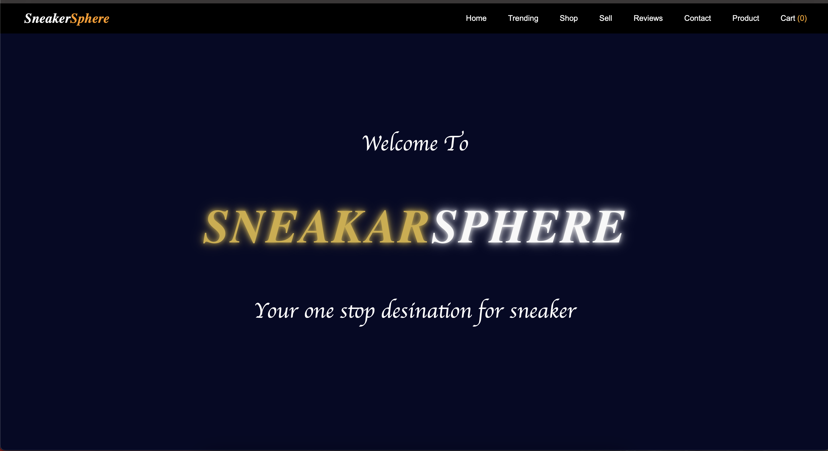

## **Code:**

B. menu/product page:

code:

<!DOCTYPE html>

<html lang="en">

<head>

<meta charset="UTF-8">

<meta name="viewport" content="width=device-width, initial-scale=1.0">

<title>Product</title>

<link rel="stylesheet" type="text/css" href="Styles.css">

</head>

<body>

<header>

<div class="logo">Sneaker<span>Sphere</span></div>

<nav>

<ul>

<li><a href="index.html">Home</a></li>

<li><a href="Trending.html">Trending</a></li>

<li><a href="shop.html">Shop</a></li>

<li><a href="sell.html">Sell</a></li>

<li><a href="reviews.html">Reviews</a></li>

<li><a href="Contact.html">Contact</a></li>

<li><a href="Product.html">Product</a></li>

<li><a href="Cart.html">Cart <span class="cart-count">(0)</span></a></li>

</ul>

</nav>

</header>

<section class="shop">

<h2>Shop Sneakers</h2>

<div class="sneaker-grid">

<div class="sneaker-card">

<img src="sneaker1.jpeg" alt="Nike Air Jordan 1">

<h3>Nike Air Jordan 1</h3>

<p>15995/-</p>

<button onclick="addProduct({name: 'Nike Air Jordan 1', price: 15995, image: 'sneaker1.jpeg'})">Add to Cart</button>

</div>

<div class="sneaker-card">

<img src="sneaker2.jpg" alt="Adidas Yeezy Boost">

<h3>Adidas Yeezy Boost</h3>

<p>12000/-</p>

<button onclick="addProduct({name: 'Adidas Yeezy Boost', price: 12000})">Add to Cart</button>

</div>

<div class="sneaker-card">

<img src="sneaker3.jpg" alt="Puma RS-X">

<h3>Puma RS-X</h3>

<p>8295/-</p>

<button onclick="addProduct({name: 'Puma RS-X', price: 8295})">Add to Cart</button>

</div>

<div class="sneaker-card">

<img src="Nikedunk.png" alt="Nike Dunk">

<h3>Nike Dunk</h3>

<p>10595/-</p>

<button onclick="addProduct({name: 'Nike Dunk', price: 10595})">Add to Cart</button>

</div>

<div class="sneaker-card">

<img src="adidassamba.avif" alt="Adidas Samba">

<h3>Adidas Samba</h3>

<p>8000/-</p>

<button onclick="addProduct({name: 'Adidas Samba', price: 8000})">Add to Cart</button>

</div>

<div class="sneaker-card">

<img src="onitsuka.webp" alt="Onitsuka Tiger Mexico 66">

<h3>Onitsuka Tiger Mexico 66</h3>

<p>12990/-</p>

<button onclick="addProduct({name: 'Onitsuka Tiger Mexico 66', price: 12990})">Add to Cart</button>

</div>

</div>

</section>

<script src="Cart.js"></script>

<footer>

<p>&copy; 2025 SneakerSphere. All Rights Reserved.</p>

</footer>

</body>

</html>

## **Output:**

B. menu/product page output:

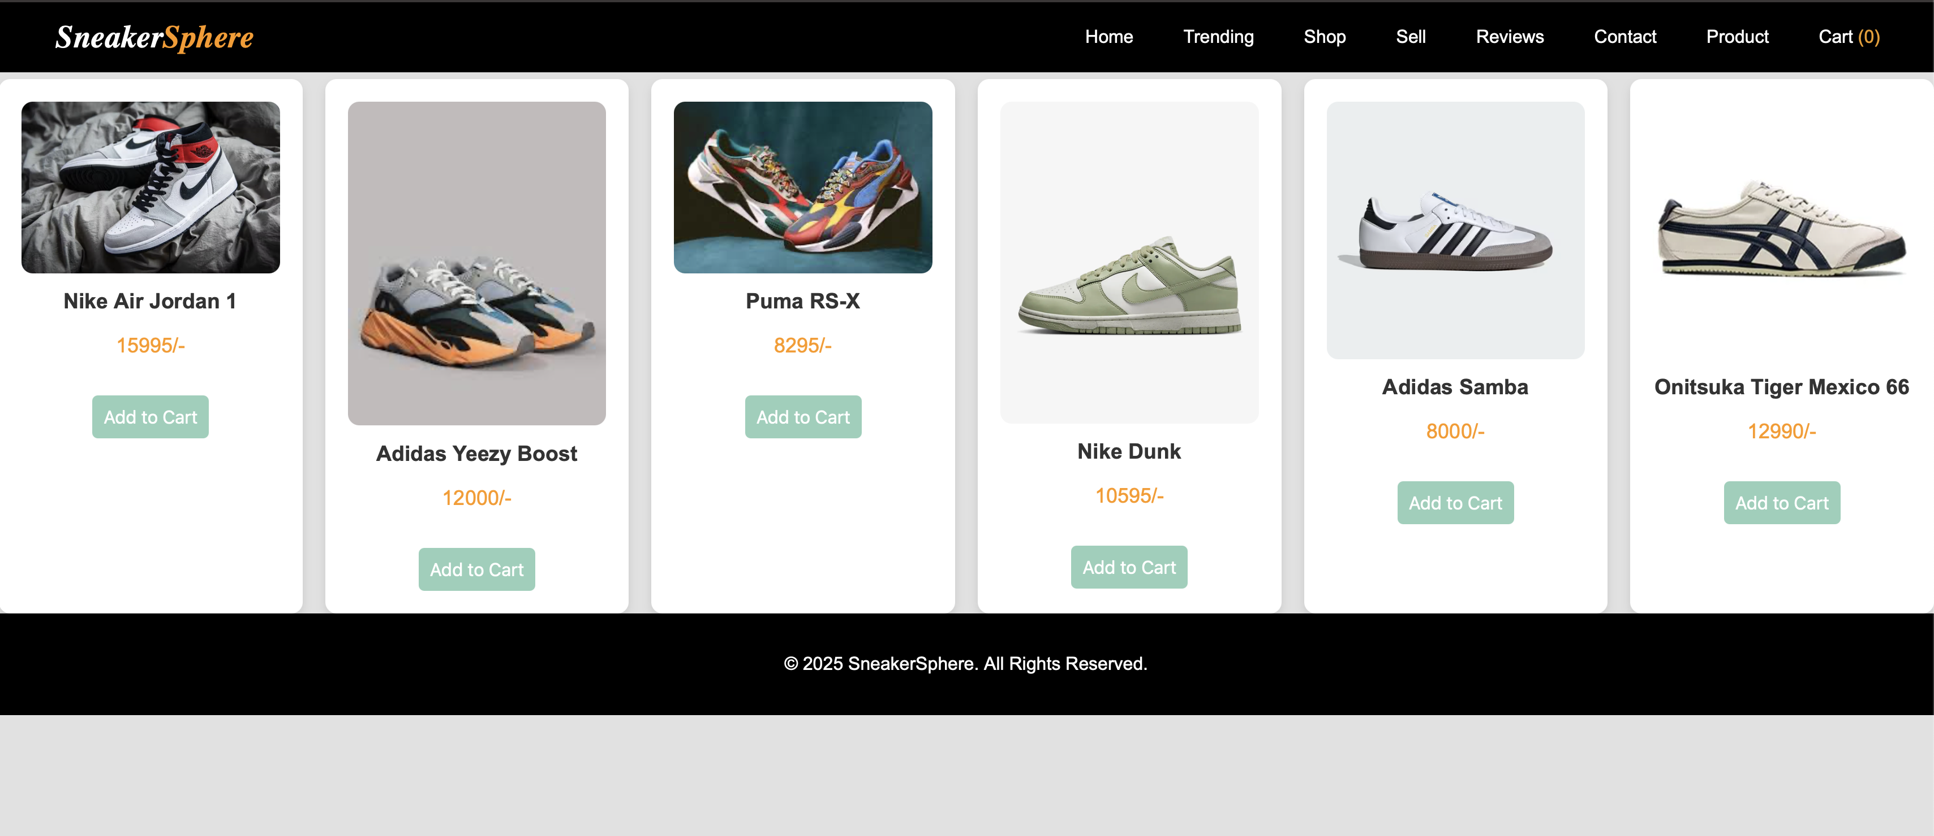

## **Code:**

C. cart page:

code:

<!DOCTYPE html>

<html lang="en">

<head>

<meta charset="UTF-8">

<meta name="viewport" content="width=device-width, initial-scale=1.0">

<title>Cart - SneakerSphere</title>

<link rel="stylesheet" type="text/css" href="Styles.css">

</head>

<body>

<header>

<div class="logo">Sneaker<span>Sphere</span></div>

<nav>

<ul>

<li><a href="index.html">Home</a></li>

<li><a href="Trending.html">Trending</a></li>

<li><a href="shop.html">Shop</a></li>

<li><a href="sell.html">Sell</a></li>

<li><a href="reviews.html">Reviews</a></li>

<li><a href="Contact.html">Contact</a></li>

<li><a href="Product.html">Product</a></li>

</ul>

</nav>

</header>

<main>

<h1>Your Cart</h1>

<div class="cart-container">

<div class="cart-items"></div>

</div>

<div class="cart-summary">

<h2>Order Summary</h2>

<p><strong>Total Items:</strong> <span id="total-items">0</span></p>

<p>Total Price: <span class="cart-total">0/-</span></p>

<div class="checkout-section">

<button id="checkout-button">Proceed to Checkout</button>

</div>

</div>

</div>

</main>

<footer>

<p>&copy; 2025 SneakerSphere. All rights reserved.</p>

</footer>

<script src="Cart.js"></script>

</body>

</html>

## **Output:**

C. cart page output:

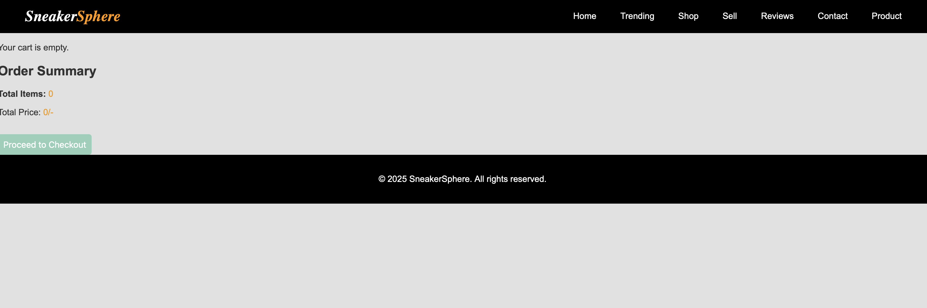

## **Code:**

D. about us page:

code:

<!DOCTYPE html>

<html lang="en">

<head>

<meta charset="UTF-8">

<meta name="viewport" content="width=device-width, initial-scale=1">

<title>About Us | Sneaker Sphere</title>

<style>

body {

margin: 0;

font-family: 'Segoe UI', Tahoma, Geneva, Verdana, sans-serif;

background-color: #f4f4f4;

color: #333;

}

header {

background-color: #000;

color: #fff;

padding: 20px 40px;

text-align: center;

}

nav a {

color: #fff;

margin: 0 15px;

text-decoration: none;

font-weight: bold;

}

.container {

max-width: 1000px;

margin: 40px auto;

padding: 0 20px;

}

h1 {

text-align: center;

color: #222;

}

.section {

margin-bottom: 40px;

}

.section h2 {

color: #555;

}

.team {

display: flex;

flex-wrap: wrap;

gap: 20px;

}

.team-member {

background-color: #fff;

border-radius: 8px;

padding: 15px;

flex: 1 1 calc(33.333% - 40px);

box-shadow: 0 2px 5px rgba(0, 0, 0, 0.1);

text-align: center;

}

.team-member img {

border-radius: 50%;

width: 120px;

height: 120px;

object-fit: cover;

margin-bottom: 10px;

}

footer {

background-color: #000;

color: #ccc;

text-align: center;

padding: 20px;

margin-top: 60px;

}

@media (max-width: 768px) {

.team-member {

flex: 1 1 100%;

}

}

</style>

</head>

<body>

<header>

<h1>Sneaker Sphere</h1>

<nav>

<a href="index.html">Home</a>

<a href="products.html">Products</a>

<a href="cart.html">Cart</a>

<a href="about.html">About</a>

<a href="contact.html">Contact</a>

</nav>

</header>

<div class="container">

<h1>About Us</h1>

<div class="section">

<h2>Our Story</h2>

<p>Sneaker Sphere was born out of a passion for sneakers and street culture. Founded in 2022 by a group of sneakerheads, our mission is to create the ultimate digital space for sneaker lovers, collectors, and resellers. We believe sneakers are more than just footwear—they’re a form of self-expression and a way of life.</p>

</div>

<div class="section">

<h2>Our Mission</h2>

<p>We aim to build a trusted platform that offers exclusive releases, the latest drops, and rare finds—all in one place. Our vision is to become the go-to destination for all things sneakers, offering a seamless shopping experience powered by technology and fueled by passion.</p>

</div>

<div class="section">

<h2>Meet Our Team</h2>

<div class="team">

<div class="team-member">

<img src="121.webp" alt="Founder">

<h3>Manthan Sasane</h3>

<p>Founder & CEO</p>

</div>

<div class="team-member">

<img src="121.webp" alt="Tech Lead">

<h3>Rohan</h3>

<p>Head of Tech & UX</p>

</div>

<div class="team-member">

<img src="121.webp" alt="Marketing">

<h3>Yash </h3>

<p>Marketing Strategist</p>

</div>

</div>

</div>

</div>

<footer>

&copy; 2025 Sneaker Sphere. All Rights Reserved.

</footer>

</body>

</html>

## **Output:**

D. about us page output:

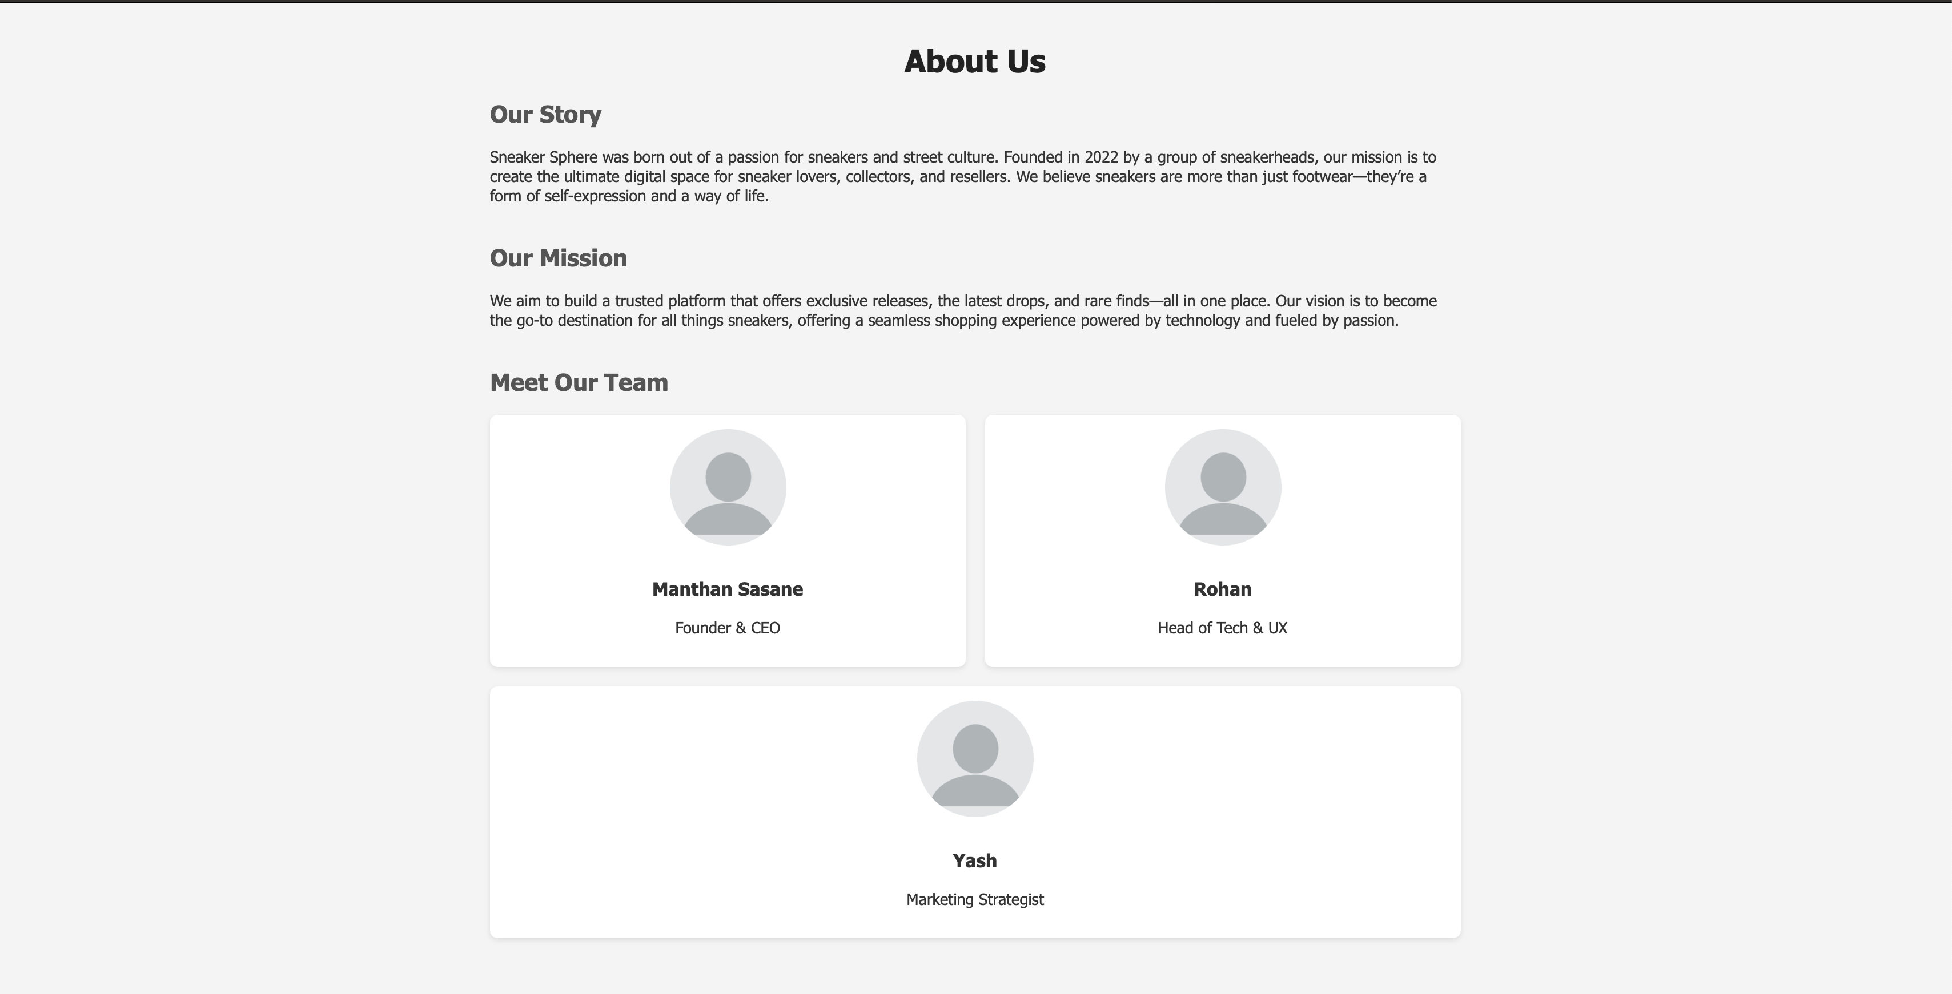

## **Code:**

E. contact us page:

code:

<!DOCTYPE html>

<html lang="en">

<head>

<meta charset="UTF-8">

<meta name="viewport" content="width=device-width, initial-scale=1.0">

<title>Contact Us - SneakerSphere</title>

<link rel="stylesheet" href="Styles.css">

</head>

<body>

<header>

<div class="logo">Sneaker<span>Sphere</span></div>

<nav>

<ul>

<li><a href="index.html">Home</a></li>

<li> <a href = "Trending.html">Trending</a></li>

<li><a href="#">Shop</a></li>

<li><a href="#">Sell</a></li>

<li><a href="Reviwes.html">Reviews</a></li>

<li><a href="Product.html">Product</a></li>

</ul>

</nav>

</header>

<section class="contact">

<h2>Contact Us</h2>

<p>Have questions or need support? Reach out to us!</p>

<div class="contact-container">

<div class="contact-form">

<h3>Send Us a Message</h3>

<form action="#" method="POST">

<input type="text" name="name" placeholder="Your Name" required>

<input type="email" name="email" placeholder="Your Email" required>

<textarea name="message" placeholder="Your Message" rows="5" required></textarea>

<button type="submit" class="btn">Send Message</button>

</form>

</div>

<div class="contact-info">

<h3>Our Contact Info</h3>

<p><strong>Email:</strong> support@sneakersphere.com</p>

<p><strong>Phone:</strong> +918976543210</p>

<p><strong>Address:</strong> Sr.no 44,BizComplex 3rd floor,Hadapsar industrial estate ,Pune 411028 .</p>

<div class="social-media">

<a href="#"><img src="facebook.png" alt="Facebook"></a>

<a href="#"><img src="instagram.png" alt="Instagram"></a>

<a href="#"><img src="twitter-bird.png" alt="Twitter"></a>

</div>

</div>

</div>

</section>

<footer>

<p>&copy; 2025 SneakerSphere. All Rights Reserved.</p>

</footer>

</body>

</html>

## **Output:**

E. contact us page output:

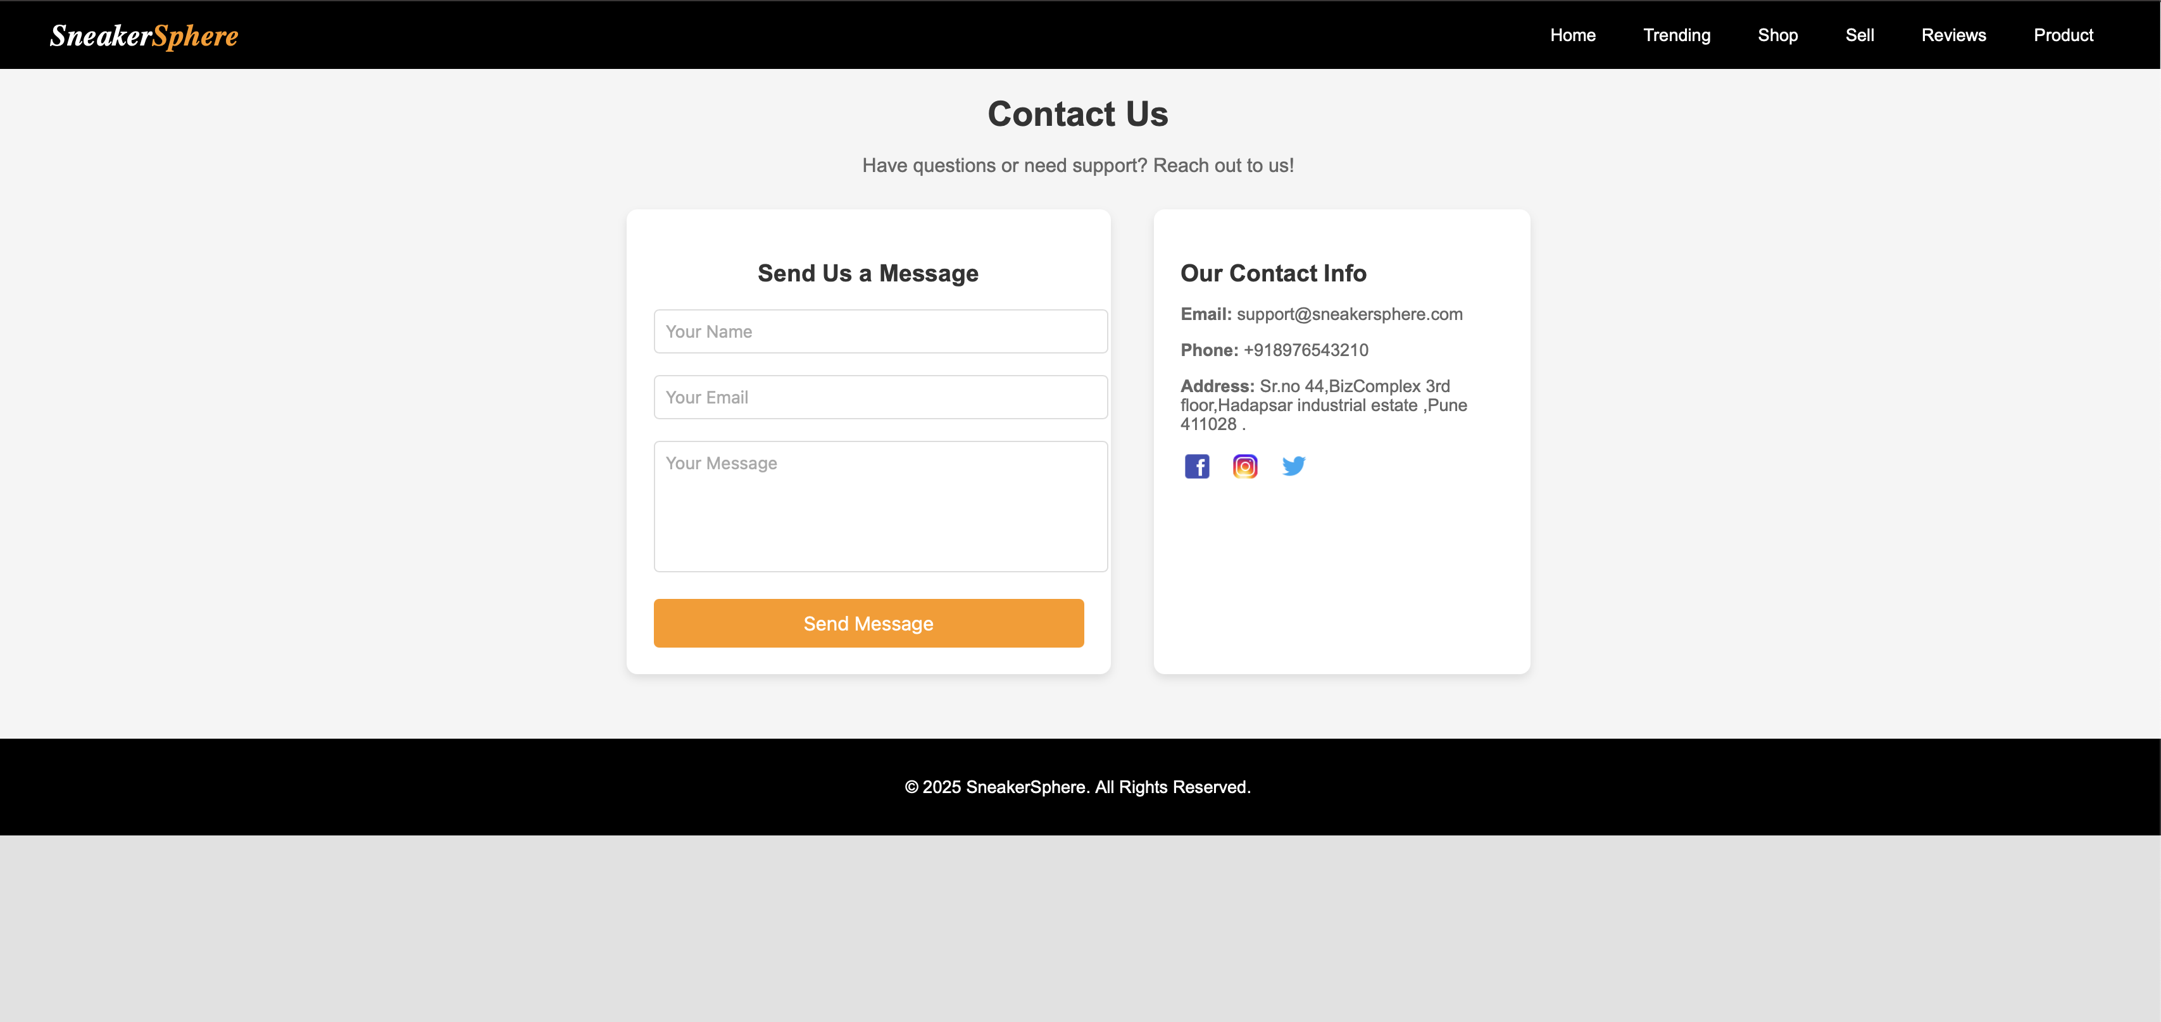

## **Code:**

F. registration page:

code:

<!DOCTYPE html>

<html lang="en">

<head>

<meta charset="UTF-8" />

<meta name="viewport" content="width=device-width, initial-scale=1.0"/>

<title>Register | Sneaker Sphere</title>

<style>

body {

background-color: #f8f8f8;

font-family: 'Segoe UI', Tahoma, Geneva, Verdana, sans-serif;

}

.form-container {

width: 400px;

margin: 80px auto;

padding: 30px;

background-color: #fff;

box-shadow: 0 4px 8px rgba(0,0,0,0.1);

border-radius: 10px;

}

h2 {

text-align: center;

margin-bottom: 20px;

color: #111;

}

input, select {

width: 100%;

padding: 12px;

margin-bottom: 15px;

border: 1px solid #ccc;

border-radius: 6px;

font-size: 14px;

}

button {

width: 100%;

padding: 12px;

background-color: #000;

color: #fff;

border: none;

border-radius: 6px;

font-size: 16px;

cursor: pointer;

}

button:hover {

background-color: #333;

}

.login-link {

text-align: center;

margin-top: 15px;

}

.login-link a {

color: #000;

text-decoration: none;

font-weight: bold;

}

</style>

</head>

<body>

<div class="form-container">

<h2>Register to Sneaker Sphere</h2>

<form action="register.php" method="post">

<input type="text" name="fullname" placeholder="Full Name" required />

<input type="email" name="email" placeholder="Email" required />

<input type="password" name="password" placeholder="Password" required />

<input type="password" name="confirm_password" placeholder="Confirm Password" required />

<select name="role" required>

<option value="">Select Role</option>

<option value="user">User</option>

<option value="admin">Admin</option>

</select>

<button type="submit">Register</button>

</form>

<div class="login-link">

Already registered? <a href="login.html">Login here</a>

</div>

</div>

</body>

</html>

## **Output:**

F. registration page output:



## **Code:**

G. login page:

code:

<!DOCTYPE html>

<html lang="en">

<head>

<meta charset="UTF-8" />

<meta name="viewport" content="width=device-width, initial-scale=1.0"/>

<title>Login | Sneaker Sphere</title>

<style>

body {

background-color: #f8f8f8;

font-family: 'Segoe UI', Tahoma, Geneva, Verdana, sans-serif;

}

.form-container {

width: 400px;

margin: 100px auto;

padding: 30px;

background-color: #fff;

box-shadow: 0 4px 8px rgba(0,0,0,0.1);

border-radius: 10px;

}

h2 {

text-align: center;

margin-bottom: 20px;

color: #111;

}

input {

width: 100%;

padding: 12px;

margin-bottom: 15px;

border: 1px solid #ccc;

border-radius: 6px;

font-size: 14px;

}

button {

width: 100%;

padding: 12px;

background-color: #000;

color: #fff;

border: none;

border-radius: 6px;

font-size: 16px;

cursor: pointer;

}

button:hover {

background-color: #333;

}

.register-link {

text-align: center;

margin-top: 15px;

}

.register-link a {

color: #000;

text-decoration: none;

font-weight: bold;

}

</style>

</head>

<body>

<div class="form-container">

<h2>Login to Sneaker Sphere</h2>

<form action="login.php" method="post">

<input type="email" name="email" placeholder="Email" required />

<input type="password" name="password" placeholder="Password" required />

<button type="submit">Login</button>

</form>

<div class="register-link">

Don't have an account? <a href="register.html">Register here</a>

</div>

</div>

</body>

</html>

## **Output:**

G. login page output:



### **1. Home Page (HTML)**

**Theory:** The homepage serves as the digital front door of the Sneaker Sphere website. It must effectively communicate the brand's identity and instantly engage the visitor. The homepage should contain eye-catching visuals such as high-quality images or sliders showcasing featured sneakers, trending collections, or new arrivals. Important elements include a well-structured navigation bar, featured sections for best-sellers, and call-to-action buttons (e.g., Shop Now, Sign Up). HTML is used to structure these elements semantically using tags such as <header>, <nav>, <main>, <section>, <footer>, etc.

**Objective:**

* Introduce visitors to the Sneaker Sphere brand.
* Provide a clear path to explore products, register, or log in.
* Enhance user engagement through visually appealing layout and intuitive structure.
* Ensure responsive design for mobile and desktop users.

### **2. Menu/Product Page (HTML)**

**Theory:** The product page displays all available sneaker items, categorized appropriately by brand, type, or release. It requires semantic HTML to separate sections, product cards for each item, and accessible image/text markup. The layout should promote easy browsing and interaction, with each item including a thumbnail image, product name, price, and a button to add to the cart. Advanced implementations might involve tabs or filters.

**Objective:**

* Showcase all available sneakers under clearly defined categories.
* Allow users to view key information at a glance (price, brand, etc.).
* Make it easy to add products to the shopping cart.
* Enhance user decision-making through descriptive product displays.

### **3. Cart Page (HTML)**

**Theory:** The cart page serves as a staging area where customers can review, update, or remove items before checkout. HTML structures the layout, enabling interaction through buttons for quantity update or delete. Each product row includes a small image, name, price, quantity input, and total cost. The cart total and checkout button must be prominently visible.

**Objective:**

* Allow customers to view all selected items before purchase.
* Facilitate quantity updates and item removal.
* Display real-time total cost for easy calculation.
* Offer a clear path to checkout.

### **4. About Us Page (HTML)**

**Theory:** This page communicates Sneaker Sphere’s story, mission, values, and team. HTML is used to structure text, images, and potentially timeline or quote sections. Strong storytelling builds trust and brand connection. Dividing content into readable chunks using headings, paragraphs, and visual elements enhances user experience.

**Objective:**

* Build trust and brand transparency with visitors.
* Share the journey and people behind the platform.
* Use storytelling to form emotional connections with users.
* Improve SEO with structured content.

### **5. Contact Page (HTML)**

**Theory:** The contact page allows visitors to get in touch with Sneaker Sphere via a structured form. HTML provides form fields (e.g., Name, Email, Subject, Message) and buttons. It may also include contact details, location maps, or business hours. Correct use of the <form> element and input types ensures accessibility and usability.

**Objective:**

* Offer a direct communication channel for users.
* Capture user queries, feedback, or complaints effectively.
* Enhance trust by being reachable.
* Ensure form is accessible and easy to use.

### **6. Admin/User Registration Form (HTML)**

**Theory:** Registration forms collect essential user details for account creation. Using <form>, <input>, <select>, and <button>, this page is structured to capture fields like name, email, password, and user type (admin/user). It must also support field labels and placeholders for clarity.

**Objective:**

* Allow new users or admins to create accounts.
* Ensure data capture is intuitive and structured.
* Improve user onboarding experience.
* Lay the groundwork for personalized experiences.

### **7. Admin/User Login Form (HTML)**

**Theory:** The login page facilitates secure access to the user or admin dashboard. HTML provides form elements for email and password with secure input types. Basic form validation ensures completeness. This is the entry point for personalized content.

**Objective:**

* Provide secure access to personalized dashboards.
* Authenticate users using login credentials.
* Separate user and admin privileges.
* Enable a gateway to advanced features.

### Conclusion:

To conclude, the HTML phase of the Sneaker Sphere project marks the beginning of actual website implementation. By creating key structural pages such as the homepage, product listing, cart, about us, and contact page, a solid front-end framework has been established. Each page was carefully structured with semantic HTML elements to ensure accessibility and maintainability. The registration and login forms were also implemented using form elements with placeholders and appropriate input types, setting the foundation for future interactivity. These HTML structures serve as the backbone of the site, ensuring consistent navigation and content presentation across different pages. As a result, users can interact with the Sneaker Sphere website through intuitive page flows, while the admin interface lays the groundwork for back-end integration. This phase brings the visual and navigational blueprint to life and is essential for linking static designs to future dynamic functionalities using JavaScript and PHP.

Experiment 3

## **Problem Statement:**

CSS

1. Enhance the layout of the Sneaker sphere website using CSS Grid for the home page.
2. Use CSS Grid to layout the menu/product items in a structured and style the menu categories with appropriate headings, spacing, separators, images, descriptions, and prices.

Home Page Layout Enhancement (CSS Grid)

**Theory:** Using CSS Grid for the Sneaker Sphere home page allows for a highly flexible and responsive design. Grid layout enables the arrangement of content into rows and columns, making it easier to organize sections like featured products, banners, and promotional content in a structured and visually pleasing manner. Grid helps in aligning and spacing items consistently across various screen sizes. CSS Grid is ideal for laying out product items in a uniform grid system on the menu/product page. It helps in separating categories, styling them distinctly, and aligning items within those categories neatly. Each product can be placed in a grid cell, with images, titles, descriptions, and prices styled with consistent spacing and typography.

**Objective:**

Apply CSS Grid to structure homepage elements effectively.

Ensure responsive layout across mobile, tablet, and desktop views.

Improve visual hierarchy and content accessibility.

Enhance aesthetics and user navigation.

Organize products into structured, visually balanced grid layouts.

Use spacing and styling to separate and highlight product categories.

Improve readability with headings, separators, and consistent formatting.

Enhance overall user experience by making browsing effortless and appealing.

a.Enhance the layout of the Sneaker sphere website using CSS Grid for the home page.

Code:.

btn {

border: none; /* Remove borders */

color: white; /* White text */

padding: 12px 16px; /* Some padding */

font-size: 16px; /* Set a font size */

cursor: pointer; /* Mouse pointer on hover */

}

.new_arrivals{

text-align: center;

padding: auto;

}

.new_arrivals h2{

color: rgb(0, 0, 0);

font-size: 28px;

margin-bottom: 20px;

}

.shop-container {

text-align: center;

padding: 80px 20px;

background-color: #061525;

color: white;

}

.shop-container h2 {

font-size: 32px;

text-transform: uppercase;

color: #ff9800;

letter-spacing: 2px;

margin-bottom: 30px;

}

.shop-grid {

display: flex;

justify-content: center;

flex-wrap: wrap;

gap: 20px;

}

.shop-card {

background: white;

padding: 20px;

border-radius: 10px;

text-align: center;

box-shadow: 0px 4px 8px rgba(0, 0, 0, 0.1);

width: 250px;

transition: transform 0.3s ease-in-out;

}

.shop-card:hover {

transform: scale(1.05);

}

.shop-card img {

width: 100%;

border-radius: 10px;

}

.shop-card h3 {

margin: 10px 0;

font-size: 20px;

color: #333;

}

.shop-card p {

font-size: 18px;

color: #ff9800;

font-weight: bold;

}

.btn-shop {

background: #ff9800;

color: white;

padding: 10px 15px;

font-size: 16px;

text-decoration: none;

border-radius: 5px;

display: inline-block;

margin-top: 10px;

transition: background 0.3s;

}

.btn-shop:hover {

background: #dcbe71;

}

Output:

**Conclusion:**

In conclusion, integrating CSS Grid into the Sneaker Sphere website significantly enhanced the user interface by enabling responsive and visually structured layouts. CSS Grid was applied effectively to the homepage, ensuring a clean and flexible grid system that adapts across devices. The product page benefited from grid-based categorization, providing clear separation between different sneaker types and styles, improving user navigation. Headings, images, descriptions, and pricing information were neatly aligned, contributing to a polished browsing experience. Grid usage also supports scalability, allowing new product categories or promotional banners to be added without redesigning the layout. This phase demonstrated how proper CSS architecture can transform a static HTML skeleton into a professional and user-friendly storefront. Overall, the use of CSS Grid aligns with modern web design principles and sets a strong visual foundation for further styling and interactivity.

**Experiment 4**

**Problem Statement:**

1. Enhance the cart page to make it user-friendly and visually appealing. Style the cart items with appropriate margins, paddings, and input field styles to provide a seamless shopping experience.
2. Enhance and style the about us page with appropriate margins, paddings, and input field styles.
3. Enhance and style the contact page to make it user-friendly and visually appealing. Style the contact form with appropriate margins, paddings, and input field styles.
4. Enhance and style the admin/user registration form with appropriate margins, paddings, and input field styles.
5. Enhance and style the admin/user login form with appropriate margins, paddings, and input field styles.

**Theory:**  
 CSS (Cascading Style Sheets) allows separation of design from structure, enabling developers to style HTML elements with colors, fonts, spacing, and animations. In the Sneaker Sphere website, CSS is responsible for making the site visually engaging and consistent with modern design trends. It controls elements like hover effects, transitions, responsive breakpoints, and visual feedback (e.g., highlighting selected products or buttons).

**Key concepts include:**

Selectors, properties, and values

Box model

Flexbox and Grid for layout

Pseudo-classes (e.g., :hover, :focus)

Media queries for responsiveness

Custom fonts and variables for maintainability

**Objective:**

Apply consistent and modern visual themes across the site.

Make the UI more interactive and engaging via animations and hover effects.

Ensure the site adapts to different screen sizes and devices.

Improve usability and accessibility through visual cues and spacing.

1. Enhance the cart page to make it user-friendly and visually appealing. Style the cart items with appropriate margins, paddings, and input field styles to provide a seamless shopping experience.

Code:

.cart-container {

display: flex;

flex-direction: column;

gap: 2rem;

max-width: 800px;

margin: auto;

background-color: white;

padding: 2rem;

border-radius: 10px;

box-shadow: 0 0 10px rgba(0, 0, 0, 0.1);

}

.cart-items {

border-bottom: 1px solid #ccc;

padding-bottom: 1rem;

}

.cart-item {

display: flex;

justify-content: space-between;

margin-bottom: 1rem;

}

.cart-summary h2 {

margin-bottom: 1rem;

}

.cart-summary p {

font-size: 1rem;

margin: 0.5rem 0;

}

.cart-total {

font-weight: bold;

color: #e53935;

}

.checkout-section {

margin-top: 1.5rem;

}

#checkout-button {

background-color: #80cbc4;

color: white;

border: none;

padding: 0.75rem 1.5rem;

font-size: 1rem;

cursor: pointer;

border-radius: 5px;

transition: background 0.3s ease;

}

#checkout-button:hover {

background-color: #4db6ac;

}

Output:

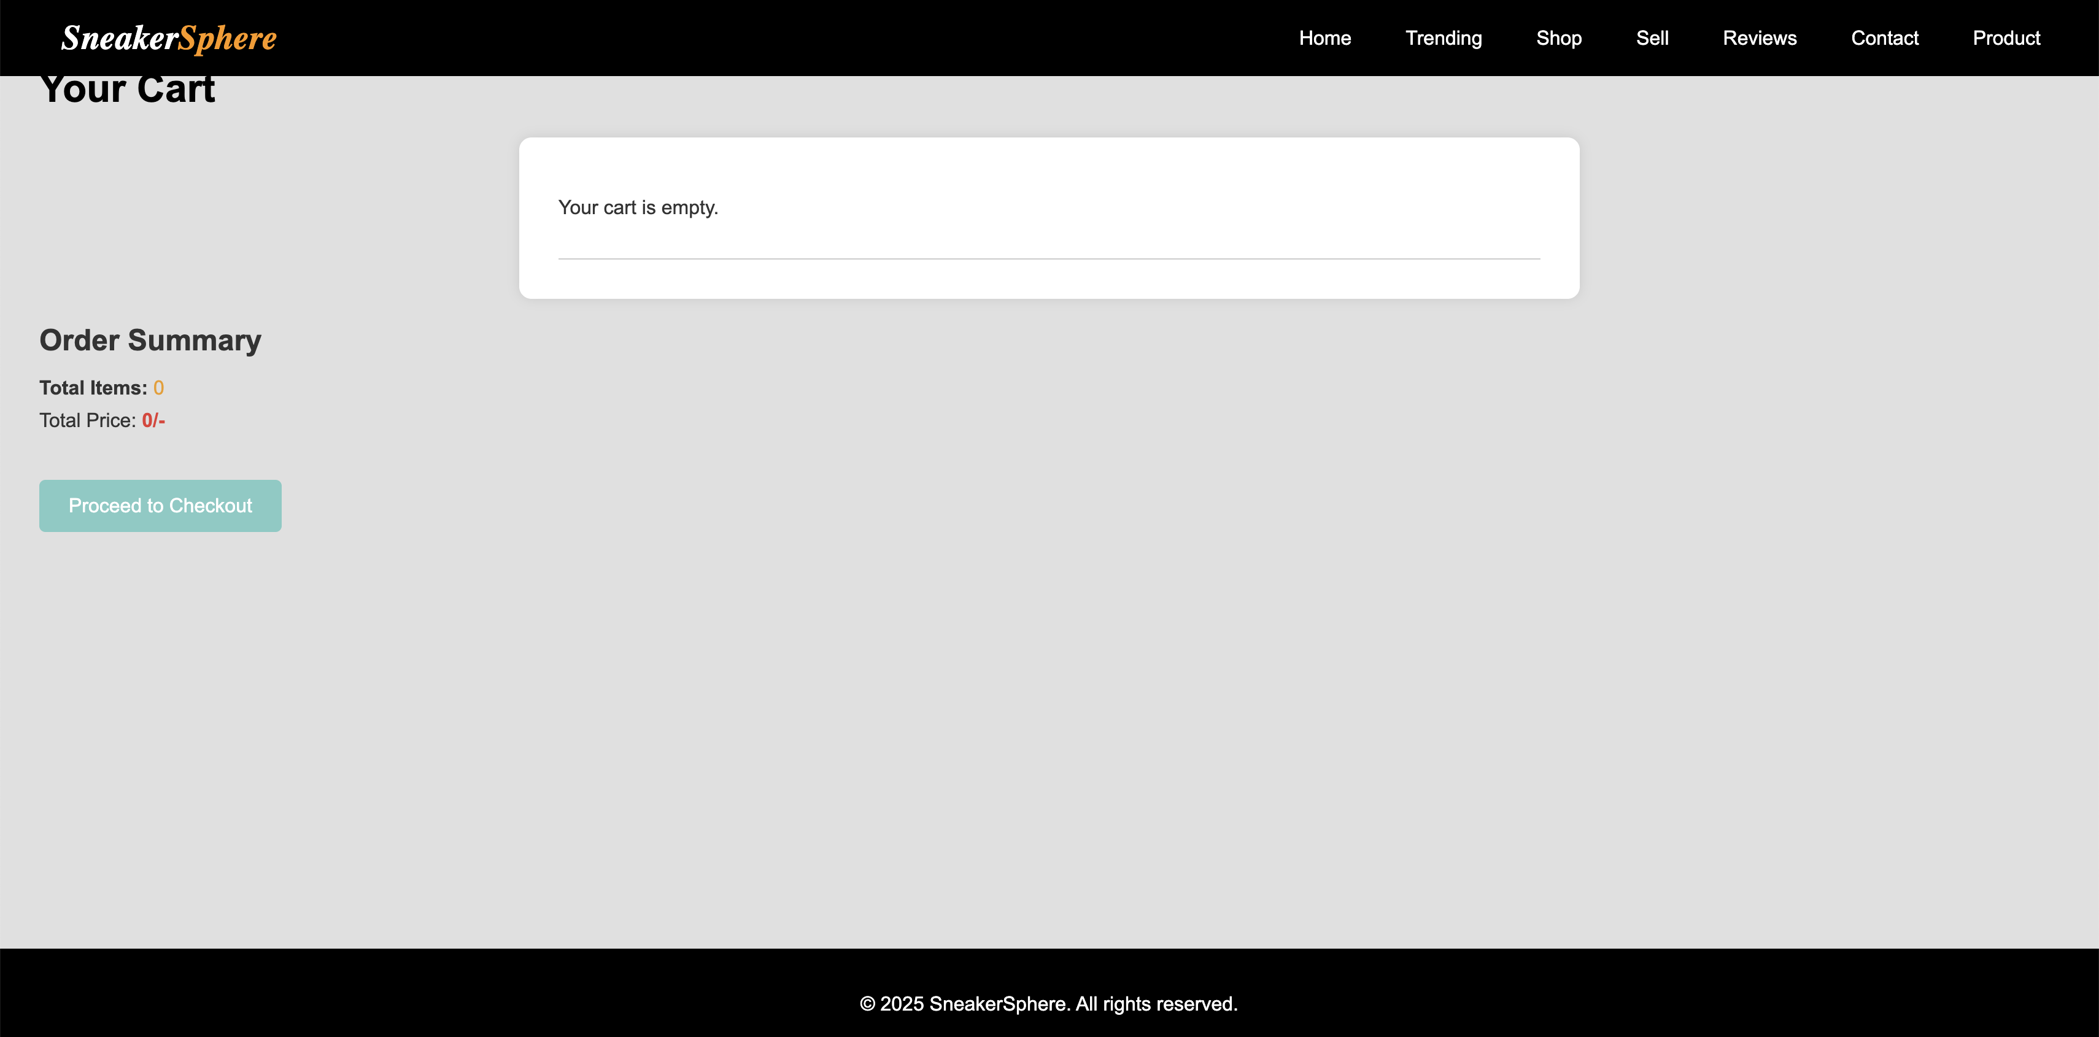

1. Enhance and style the about us page with appropriate margins, paddings, and input field styles.

Code:

.container {

max-width: 1000px;

margin: 40px auto;

padding: 0 20px;

}

h1 {

text-align: center;

color: #222;

}

.section {

margin-bottom: 40px;

}

.section h2 {

color: #555;

}

.team {

display: flex;

flex-wrap: wrap;

gap: 20px;

}

.team-member {

background-color: #fff;

border-radius: 8px;

padding: 15px;

flex: 1 1 calc(33.333% - 40px);

box-shadow: 0 2px 5px rgba(0, 0, 0, 0.1);

text-align: center;

}

.team-member img {

border-radius: 50%;

width: 120px;

height: 120px;

object-fit: cover;

margin-bottom: 10px;

}

footer {

background-color: #000;

color: #ccc;

text-align: center;

padding: 20px;

margin-top: 60px;

}

@media (max-width: 768px) {

.team-member {

flex: 1 1 100%;

}

}

Output:



1. Enhance and style the contact page to make it user-friendly and visually appealing. Style the contact form with appropriate margins, paddings, and input field styles.

Code:

.contact {

text-align: center;

padding: 60px 20px;

background-color: #f5f5f5;

}

.contact h2 {

font-size: 32px;

margin-bottom: 10px;

}

.contact p {

font-size: 18px;

color: #666;

margin-bottom: 30px;

}

.contact-container {

display: flex;

justify-content: center;

gap: 40px;

flex-wrap: wrap;

}

.contact-form {

background: white;

padding: 25px;

border-radius: 10px;

box-shadow: 0px 4px 8px rgba(0, 0, 0, 0.1);

width: 400px;

}

.contact-form h3 {

margin-bottom: 15px;

font-size: 22px;

}

.contact-form input,

.contact-form textarea {

width: 100%;

padding: 10px;

margin-bottom: 15px;

border: 1px solid #ddd;

border-radius: 5px;

font-size: 16px;

}

.contact-form textarea {

resize: none;

}

.contact-form .btn {

display: block;

width: 100%;

background: #ff9800;

color: white;

padding: 12px;

font-size: 18px;

text-align: center;

border: none;

border-radius: 5px;

cursor: pointer;

}

.contact-form .btn:hover {

background: #e68900;

}

.contact-info {

background: white;

padding: 25px;

border-radius: 10px;

box-shadow: 0px 4px 8px rgba(0, 0, 0, 0.1);

width: 300px;

text-align: left;

}

.contact-info h3 {

font-size: 22px;

margin-bottom: 10px;

}

.contact-info p {

font-size: 16px;

margin-bottom: 10px;

}

.social-media {

display: flex;

gap: 15px;

margin-top: 15px;

}

.social-media a img {

width: 30px;

height: 30px;

transition: 0.3s;

}

.social-media a img:hover {

transform: scale(1.1);

}

Output:



1. Enhance and style the admin/user login form with appropriate margins, paddings, and input field styles.

Code:

.form-container {

width: 400px;

margin: 100px auto;

padding: 30px;

background-color: #fff;

box-shadow: 0 4px 8px rgba(0,0,0,0.1);

border-radius: 10px;

}

h2 {

text-align: center;

margin-bottom: 20px;

color: #111;

}

input {

width: 100%;

padding: 12px;

margin-bottom: 15px;

border: 1px solid #ccc;

border-radius: 6px;

font-size: 14px;

}

button {

width: 100%;

padding: 12px;

background-color: #000;

color: #fff;

border: none;

border-radius: 6px;

font-size: 16px;

cursor: pointer;

}

button:hover {

background-color: #333;

}

.register-link {

text-align: center;

margin-top: 15px;

}

.register-link a {

color: #000;

text-decoration: none;

font-weight: bold;

}

Output:



1. Enhance and style the admin/user register form with appropriate margins, paddings, and input field styles.

Code:

.form-container {

width: 400px;

margin: 80px auto;

padding: 30px;

background-color: #fff;

box-shadow: 0 4px 8px rgba(0,0,0,0.1);

border-radius: 10px;

}

h2 {

text-align: center;

margin-bottom: 20px;

color: #111;

}

input, select {

width: 100%;

padding: 12px;

margin-bottom: 15px;

border: 1px solid #ccc;

border-radius: 6px;

font-size: 14px;

}

button {

width: 100%;

padding: 12px;

background-color: #000;

color: #fff;

border: none;

border-radius: 6px;

font-size: 16px;

cursor: pointer;

}

button:hover {

background-color: #333;

}

.login-link {

text-align: center;

margin-top: 15px;

}

.login-link a {

color: #000;

text-decoration: none;

font-weight: bold;

}

Output:



**Conclusion:**

To conclude, the fourth phase of the Sneaker Sphere project focused on refining the visual experience by enhancing the style of all major pages using advanced CSS. Each form and content section was tailored with appropriate margins, paddings, input styles, and color themes to create a uniform and user-friendly interface. The cart page became more intuitive, allowing users to interact with items in a clear and concise layout. Similarly, the about us and contact pages gained structure and appeal, reflecting the brand's identity through visual consistency. The registration and login forms were also made more engaging and accessible, improving user trust and usability. This styling effort not only added aesthetic value but also contributed to improved accessibility, interaction flow, and mobile responsiveness. Overall, this phase elevated the look and feel of the entire site, paving the way for seamless functionality integration through JavaScript and back-end processing.

**Experiment 5**

**Problem Statement:**

1. Implement user registration and login forms for the Sneaker sphere website. These forms will allow users to create an account, log in, and access personalized features, such as saving favorite items or viewing order history.
2. User Registration Form will allow new customers to sign up and create an account on the website. The form will capture basic user details, including the name, email address, and password (not limited to these fields).
3. User Login Form will allow registered users to log into their accounts. The form will require an email address and a password to authenticate the user.
4. Provide validations for user registration and login forms to validate the input to ensure that all required fields are filled and that the email format is valid. (Contents beyond Syllabus)
5. Develop cart functionality to allow users to add items, update quantities, and remove items.

**Theory:**  
 JavaScript enhances user experience by adding interactivity and handling dynamic content without reloading the page. In the Sneaker Sphere website, JavaScript enables:

Adding/removing items from the cart using localStorage or sessionStorage

Validating forms (registration, login, contact)

Filtering or sorting products on the product page

Displaying dynamic cart totals

Showing/hiding sections based on user actions (e.g., navigation toggles, modal windows)

DOM (Document Object Model) manipulation using document.querySelector, addEventListener, and innerHTML allows updating HTML content dynamically.

**Objective:**

Enable dynamic shopping cart functionality with persistent storage.

Validate forms to enhance security and data integrity.

Create responsive, interactive behaviors for seamless navigation.

Handle real-time updates to product selection, cart summary, and UI state.

1. Implement user registration and login forms for the Sneaker sphere website. These forms will allow users to create an account, log in, and access personalized features, such as saving favorite items or viewing order history.

User Registration Form will allow new customers to sign up and create an account on the website. The form will capture basic user details, including the name, email address, and password (not limited to these fields).

User Login Form will allow registered users to log into their accounts. The form will require an email address and a password to authenticate the user.

Code:

Register.js

document.addEventListener("DOMContentLoaded", () => {

const form = document.querySelector("form");

form.addEventListener("submit", function (e) {

const password = form.password.value;

const confirmPassword = form.confirm_password.value;

const email = form.email.value;

const emailPattern = /^[^ ]+@[^ ]+\.[a-z]{2,3}$/;

if (!email.match(emailPattern)) {

alert("Please enter a valid email address.");

e.preventDefault();

return;

}

if (password.length < 6) {

alert("Password must be at least 6 characters long.");

e.preventDefault();

return;

}

if (password !== confirmPassword) {

alert("Passwords do not match.");

e.preventDefault();

return;

}

});

});

Login.js:

document.addEventListener("DOMContentLoaded", () => {

const form = document.querySelector("form");

form.addEventListener("submit", function (e) {

const email = form.email.value;

const password = form.password.value;

const emailPattern = /^[^ ]+@[^ ]+\.[a-z]{2,3}$/;

if (!email.match(emailPattern)) {

alert("Please enter a valid email address.");

e.preventDefault();

return;

}

if (password.trim() === "") {

alert("Please enter your password.");

e.preventDefault();

return;

}

});

});

1. Provide validations for user registration and login forms to validate the input to ensure that all required fields are filled and that the email format is valid. (**Contents beyond Syllabus)**

Code:

Register.js:

document.addEventListener("DOMContentLoaded", () => {

const form = document.querySelector("form");

form.addEventListener("submit", function (e) {

const fullname = form.fullname.value.trim();

const gender = form.gender.value;

const address = form.address.value.trim();

const email = form.email.value.trim();

const password = form.password.value;

const confirmPassword = form.confirm_password.value;

const role = form.role.value;

const emailPattern = /^[^ ]+@[^ ]+\.[a-z]{2,}$/i;

// Check all fields are filled

if (!fullname || !gender || !address || !email || !password || !confirmPassword || !role) {

alert("Please fill out all fields.");

e.preventDefault();

return;

}

// Email format check

if (!emailPattern.test(email)) {

alert("Please enter a valid email address.");

e.preventDefault();

return;

}

// Password length check

if (password.length < 6) {

alert("Password must be at least 6 characters long.");

e.preventDefault();

return;

}

// Password match check

if (password !== confirmPassword) {

alert("Passwords do not match.");

e.preventDefault();

}

});

});

Login.js:

document.addEventListener("DOMContentLoaded", () => {

const form = document.querySelector("form");

form.addEventListener("submit", function (e) {

const email = form.email.value.trim();

const password = form.password.value;

const emailPattern = /^[^ ]+@[^ ]+\.[a-z]{2,}$/i;

// Check both fields

if (!email || !password) {

alert("Please enter both email and password.");

e.preventDefault();

return;

}

// Email format check

if (!emailPattern.test(email)) {

alert("Please enter a valid email address.");

e.preventDefault();

}

});

});

1. Develop cart functionality to allow users to add items, update quantities, and remove items.

Code:

Cart.js:

document.addEventListener("DOMContentLoaded", () => {

const cartContainer = document.querySelector(".cart-items");

const cartTotal = document.querySelector(".cart-total");

const cartCount = document.querySelector(".cart-count");

function getCart() {

return JSON.parse(localStorage.getItem("cart")) || [];

}

function saveCart(cart) {

localStorage.setItem("cart", JSON.stringify(cart));

}

function updateCartDisplay() {

const cart = getCart();

cartContainer.innerHTML = "";

let total = 0;

if (cart.length === 0) {

cartContainer.innerHTML = "<p>Your cart is empty.</p>";

} else {

cart.forEach((item, index) => {

total += item.price * item.quantity;

cartContainer.innerHTML += `

<div class="cart-item">

<img src="${item.image}" alt="${item.name}">

<h3>${item.name}</h3>

<p>Price: ${item.price}/-</p>

<input type="number" value="${item.quantity}" min="1" data-index="${index}" class="quantity-input">

<button class="remove-btn" data-index="${index}">Remove</button>

</div>

`;

});

}

cartTotal.textContent = `${total}/-`;

cartCount.textContent = `(${cart.length})`;

saveCart(cart);

}

cartContainer.addEventListener("change", (e) => {

if (e.target.classList.contains("quantity-input")) {

const cart = getCart();

const index = e.target.getAttribute("data-index");

cart[index].quantity = parseInt(e.target.value);

saveCart(cart);

updateCartDisplay();

}

});

cartContainer.addEventListener("click", (e) => {

if (e.target.classList.contains("remove-btn")) {

const cart = getCart();

const index = e.target.getAttribute("data-index");

cart.splice(index, 1);

saveCart(cart);

updateCartDisplay();

}

});

function addProduct(prodDetails) {

let cart = getCart();

let existingItem = cart.find(item => item.name === prodDetails.name);

if (existingItem) {

existingItem.quantity++;

} else {

cart.push({...prodDetails, quantity: 1});

}

saveCart(cart);

cartCount.textContent = `(${cart.length})`;

}

window.addProduct = addProduct;

updateCartDisplay();

});

Output:

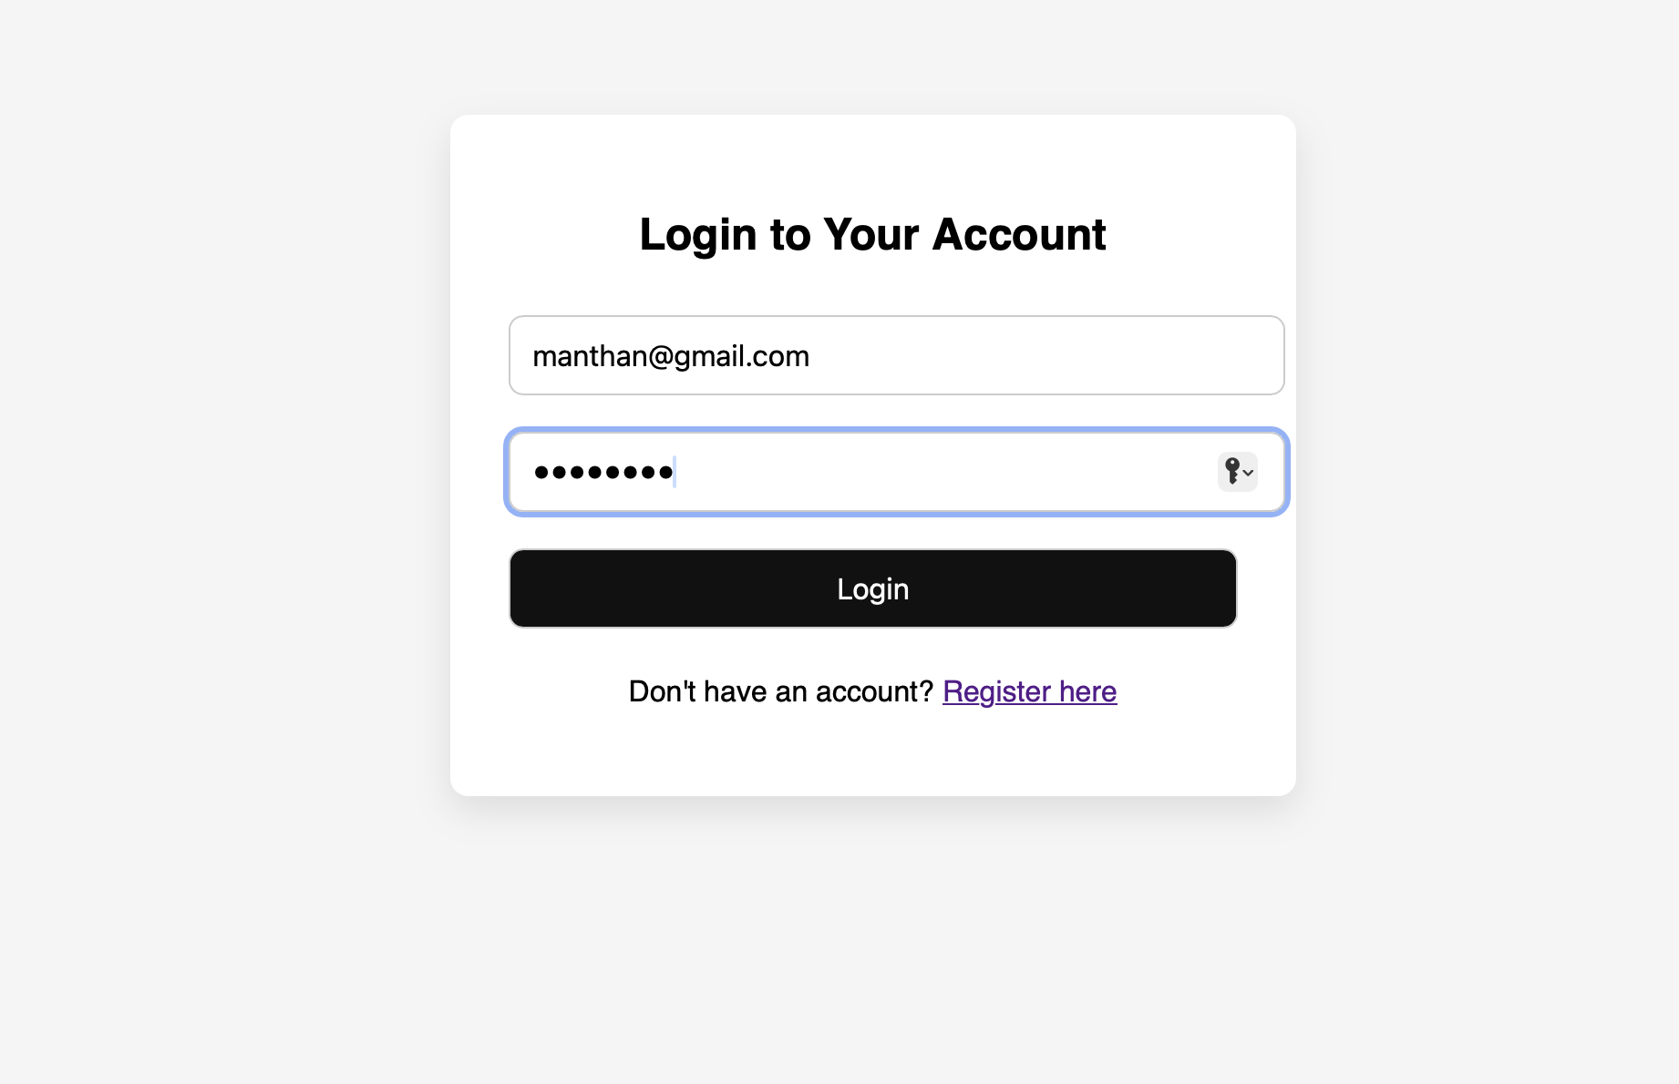

**Conclusion :** In conclusion, the JavaScript development phase introduced crucial interactivity to the Sneaker Sphere website by implementing functional user registration, login forms, and cart systems. JavaScript enabled client-side validation, ensuring that users enter valid and complete data, thereby improving form submission accuracy and user satisfaction. The cart system allowed users to dynamically add, update, and remove items—creating a smooth and real-time shopping experience. These functionalities enhanced user engagement and demonstrated the importance of a responsive frontend logic layer. JavaScript also laid the groundwork for persistent data handling, which would be extended in the next phase through localStorage. Overall, this milestone bridged static content and dynamic interaction, transforming Sneaker Sphere from a basic website to an interactive platform.

**Experiment 6**

**Problem Statement:**

1. The user login form will allow registered users to log into their accounts. The form will require an email address and a password to authenticate the user.
2. If the login is successful, the user should be redirected to the homepage or their user dashboard. (Contents beyond Syllabus)
3. Use localStorage or sessionStorage to store authentication data, such as the user’s email and login status. This ensures that once a user is logged in, they remain authenticated even after the page reloads or when they visit the site again. (Contents beyond Syllabus)
4. Save the cart data to local storage when items are added, updated, or removed. Retrieve and load the cart data from local storage when the page loads. (Contents beyond Syllabus)

### **Theory:**

A **user login form** is a key component of any interactive web application that provides personalized user experiences. It allows registered users to securely access their accounts using unique credentials—typically an **email** and a **password**. Upon submission, the system verifies the credentials either through a backend database or a predefined dataset.

Modern web applications often enhance user experience by implementing **session persistence**, where a user remains logged in even after reloading the page or revisiting the site. This is achieved using **Web Storage APIs**, namely:

* **localStorage**: Stores data with no expiration time. Data persists even after the browser is closed and reopened.
* **sessionStorage**: Stores data only for the duration of the page session. Data is cleared when the browser or tab is closed.

By saving **authentication state** and **cart information** in localStorage/sessionStorage, the application ensures a **seamless shopping experience**, allowing users to return to their cart even after navigation or accidental reload.

This technique is especially useful in projects beyond the academic syllabus, as it mimics real-world e-commerce platforms and emphasizes user-centric design.

1. The user login form will allow registered users to log into their accounts. The form will require an email address and a password to authenticate the user.

Code:

document.addEventListener("DOMContentLoaded", () => {

const form = document.getElementById("loginForm");

form.addEventListener("submit", function (e) {

e.preventDefault();

const email = form.email.value.trim();

const password = form.password.value;

const emailPattern = /^[^ ]+@[^ ]+\.[a-z]{2,}$/i;

if (!email || !password) {

alert("Please fill in both fields.");

return;

}

if (!emailPattern.test(email)) {

alert("Invalid email format.");

return;

}

// Simulate a registered user (in real apps, this comes from the database)

const users = JSON.parse(localStorage.getItem("registeredUsers")) || [];

const foundUser = users.find(user => user.email === email && user.password === password);

if (foundUser) {

sessionStorage.setItem("isLoggedIn", "true");

sessionStorage.setItem("userEmail", email);

alert("Login successful!");

window.location.href = "homepage.html"; // change this to your home/dashboard

} else {

alert("Invalid email or password.");

}

});

});

1. If the login is successful, the user should be redirected to the homepage or their user dashboard. (Contents beyond Syllabus)

Code:

if (foundUser) {

sessionStorage.setItem("isLoggedIn", "true");

sessionStorage.setItem("userEmail", email);

alert("Login successful!");

window.location.href = "index.html";

} else {

alert("Invalid email or password.");

}

});

C. Use localStorage or sessionStorage to store authentication data, such as the user’s email and login status. This ensures that once a user is logged in, they remain authenticated even after the page reloads or when they visit the site again. (Contents beyond Syllabus)

Code:

if (sessionStorage.getItem("isLoggedIn") === "true") {

console.log("User is logged in:", sessionStorage.getItem("userEmail"));

}

1. Save the cart data to local storage when items are added, updated, or removed. Retrieve and load the cart data from local storage when the page loads. (Contents beyond Syllabus)

Code:

document.addEventListener("DOMContentLoaded", () => {

if (sessionStorage.getItem("isLoggedIn") !== "true") {

alert("Please log in to access your cart.");

window.location.href = "login.html";

return;

}

const userEmail = sessionStorage.getItem("userEmail");

const cartContainer = document.querySelector(".cart-items");

const cartTotal = document.querySelector(".cart-total");

const cartCount = document.querySelector(".cart-count");

function getCart() {

return JSON.parse(localStorage.getItem(`cart_${userEmail}`)) || [];

}

function saveCart(cart) {

localStorage.setItem(`cart_${userEmail}`, JSON.stringify(cart));

}

});

Output:

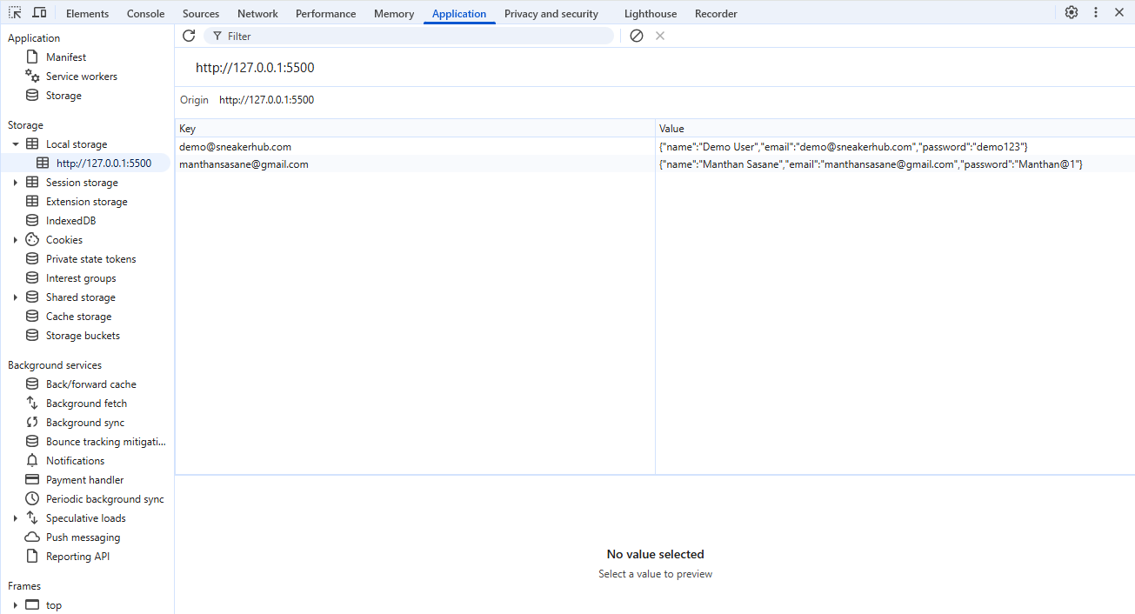

**Conclusion:**

To conclude, leveraging localStorage in this phase brought enhanced persistence and usability to the Sneaker Sphere website. By storing authentication details and cart data, the website ensures a smoother user experience even after page reloads or browser closures. This approach allows users to stay logged in and retain their cart items until they explicitly log out or clear storage, which mirrors the functionality of professional e-commerce platforms. JavaScript was used to authenticate users and redirect them based on login success while maintaining security and flow. This client-side storage mechanism enabled session management without a database, making the site functional during early development stages. Overall, this phase demonstrated how localStorage can significantly improve user experience and state management before full server-side integration.

**Experiment 7**

**Problem Statement:**

1. Develop a PHP script to handle user registration for the Sneaker sphere website. The script should accept input from users for their name, email address, password, etc. (all required fields for registration).
2. Implement error handling to notify users of any issues during registration, such as validation errors.
3. Provide feedback to the user upon successful registration, either through a confirmation message or a redirect to a login page.

**Theory:**

PHP (Hypertext Preprocessor) is a server-side scripting language used to manage form submissions, user authentication, and database interactions. In Sneaker Sphere, PHP is responsible for:

Registering and logging in users/admins

Validating and storing user data securely

Connecting to a MySQL database to retrieve and manage sneaker inventory

Handling contact form submissions and sending data to email or database

Differentiating between admin and user privileges (e.g., access to product upload, delete, or edit)

**Objective:**

Securely manage backend operations like user sessions and form processing.

Connect frontend forms to database for storing and retrieving user/product data.

Implement login and registration logic with hashed passwords.

Enable admin-side functionalities like product management.

Ensure server-side validation for additional security.

1. Develop a PHP script to handle user registration for the Sneaker Sphere website. The script should accept input from users for their name, email address, password, etc. (all required fields for registration).

Code:

Register.php :

<?php

$conn = new mysqli("localhost", "root", "", "sneakersphere");

if ($conn->connect_error) {

die("Connection failed: " . $conn->connect_error);

}

$fullname = $_POST['fullname'];

$gender = $_POST['gender'];

$address = $_POST['address'];

$email = $_POST['email'];

$password = $_POST['password'];

$confirm_password = $_POST['confirm_password'];

$role = $_POST['role'];

if ($password !== $confirm_password) {

die("Passwords do not match.");

}

$hashed_password = password_hash($password, PASSWORD_DEFAULT);

$sql = "INSERT INTO users (fullname, gender, address, email, password, role)

VALUES (?, ?, ?, ?, ?, ?)";

$stmt = $conn->prepare($sql);

$stmt->bind_param("ssssss", $fullname, $gender, $address, $email, $hashed_password, $role);

if ($stmt->execute()) {

echo "Registration successful. <a href='login.html'>Login Now</a>";

} else {

echo "Error: " . $stmt->error;

}

$stmt->close();

$conn->close();

?>

1. Implement error handling to notify users of any issues during registration, such as validation errors.

Code:

// === VALIDATION ===

if (empty($fullname) || empty($gender) || empty($address) || empty($email) || empty($password) || empty($confirm_password) || empty($role)) { $errors[] = "All fields are required."; }

if (!filter_var($email, FILTER_VALIDATE_EMAIL)) {  
 $errors[] = "Invalid email format.";  
}  
  
if ($password !== $confirm_password) {  
 $errors[] = "Passwords do not match.";  
}  
  
if (strlen($password) < 6) {  
 $errors[] = "Password must be at least 6 characters.";  
}  
  
// === IF NO ERRORS, SAVE DATA ===  
if (empty($errors)) {  
 // Hash the password for security  
 $hashed_password = password_hash($password, PASSWORD_DEFAULT);

1. Provide feedback to the user upon successful registration, either through a confirmation message or a redirect to a login page.

Code:

<body>

<div class="message">

<h2>Registration Status</h2>

<?php if (!empty($errors)): ?>

<?php foreach ($errors as $error): ?>

<p class="error"><?php echo htmlspecialchars($error); ?></p>

<?php endforeach; ?>

<a href="javascript:history.back()">← Go Back</a>

<?php endif; ?>

</div>

</body>

**Output:**

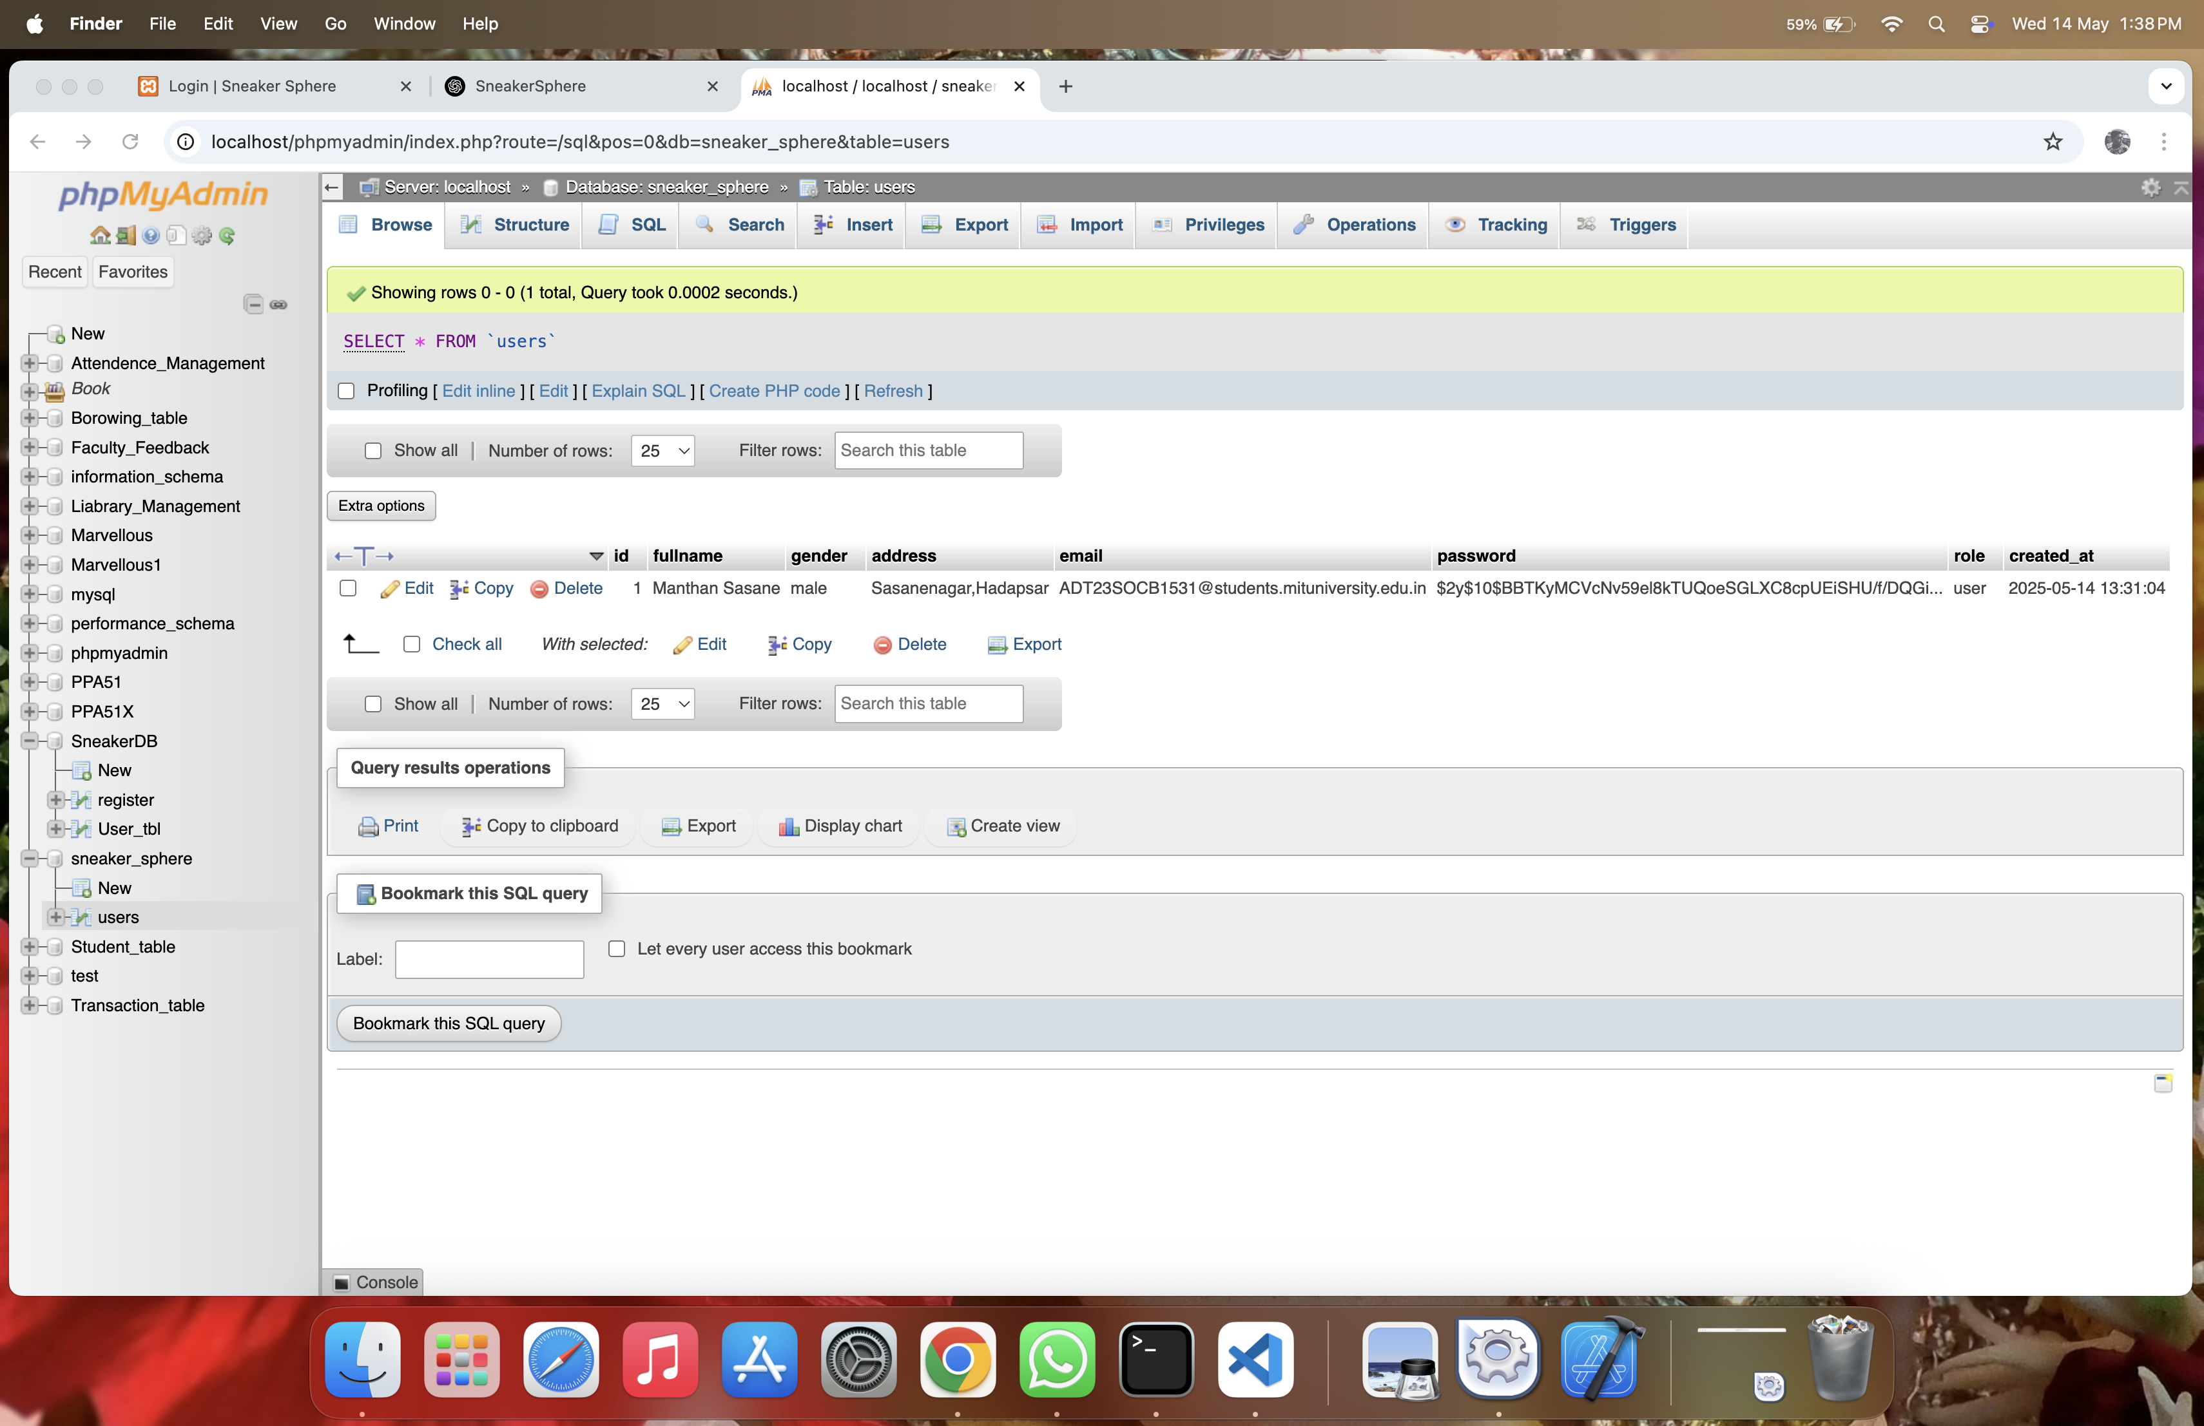

**Conclusion:**

In conclusion, the seventh phase introduced server-side scripting using PHP to handle user registration securely and efficiently. The form data submitted via HTML and validated with JavaScript was now processed on the backend, ensuring database-level integrity. PHP scripts were developed to collect user details, validate server-side inputs, check for existing accounts, and store new records. Error handling was implemented to manage validation failures, duplicate email issues, and data format problems. The feedback mechanism reassured users with success or failure messages, guiding them through the sign-up process. This integration marks a significant transition from a static to a dynamic website and forms the basis of a full-stack application. It sets the stage for future user account features such as login, order history, and dashboard functionality.

**Experiment 8**

**Problem Statement:**

1. Develop a PHP script to handle user login for the Sneaker sphere website. The script should accept input from users for their login credentials. (all required fields for login).
2. Provide feedback to the user upon successful login, either through a confirmation message or a redirect to a welcome page.
3. Implement error handling to notify users of login failures due to incorrect credentials or other errors.
4. Provide feedback to the user upon successful login, either through a welcome user name message or a redirect to a home page.

**Theory:**

PHP (Hypertext Preprocessor) is a server-side scripting language used to handle dynamic web content, such as processing login credentials and connecting to databases. For the Sneaker Sphere website, the PHP login script plays a critical role in authenticating users.

The login script:

Accepts input from login form fields (e.g., email/username and password).

Connects to a MySQL database to verify credentials.

Provides appropriate feedback based on authentication results.

Redirects users to a welcome/home page upon success.

**Objective:**

Validate user login inputs via server-side PHP.

Authenticate credentials against stored values in the database.

Redirect users upon successful login or display relevant error messages upon failure.

Provide user-friendly feedback like "Welcome, [username]" after login.

Securely manage session handling for logged-in users.

1. Develop a PHP script to handle user registration for the Sneaker Sphere website. The script should accept input from users for their name, email address, password, etc. (all required fields for registration).

Code:

Register.php :

<?php

$conn = new mysqli("localhost", "root", "", "sneakersphere");

if ($conn->connect_error) {

die("Connection failed: " . $conn->connect_error);

}

$fullname = $_POST['fullname'];

$gender = $_POST['gender'];

$address = $_POST['address'];

$email = $_POST['email'];

$password = $_POST['password'];

$confirm_password = $_POST['confirm_password'];

$role = $_POST['role'];

if ($password !== $confirm_password) {

die("Passwords do not match.");

}

$hashed_password = password_hash($password, PASSWORD_DEFAULT);

$sql = "INSERT INTO users (fullname, gender, address, email, password, role)

VALUES (?, ?, ?, ?, ?, ?)";

$stmt = $conn->prepare($sql);

$stmt->bind_param("ssssss", $fullname, $gender, $address, $email, $hashed_password, $role);

if ($stmt->execute()) {

echo "Registration successful. <a href='login.html'>Login Now</a>";

} else {

echo "Error: " . $stmt->error;

}

$stmt->close();

$conn->close();

?>

1. Implement error handling to notify users of any issues during registration, such as validation errors.

Code:

// === VALIDATION ===

if (empty($fullname) || empty($gender) || empty($address) || empty($email) || empty($password) || empty($confirm_password) || empty($role)) { $errors[] = "All fields are required."; }

if (!filter_var($email, FILTER_VALIDATE_EMAIL)) {  
 $errors[] = "Invalid email format.";  
}  
  
if ($password !== $confirm_password) {  
 $errors[] = "Passwords do not match.";  
}  
  
if (strlen($password) < 6) {  
 $errors[] = "Password must be at least 6 characters.";  
}  
  
// === IF NO ERRORS, SAVE DATA ===  
if (empty($errors)) {  
 // Hash the password for security  
 $hashed_password = password_hash($password, PASSWORD_DEFAULT);

1. Provide feedback to the user upon successful registration, either through a confirmation message or a redirect to a login page.

Code:

<body>

<div class="message">

<h2>Registration Status</h2>

<?php if (!empty($errors)): ?>

<?php foreach ($errors as $error): ?>

<p class="error"><?php echo htmlspecialchars($error); ?></p>

<?php endforeach; ?>

<a href="javascript:history.back()">← Go Back</a>

<?php endif; ?>

</div>

</body>

Output:

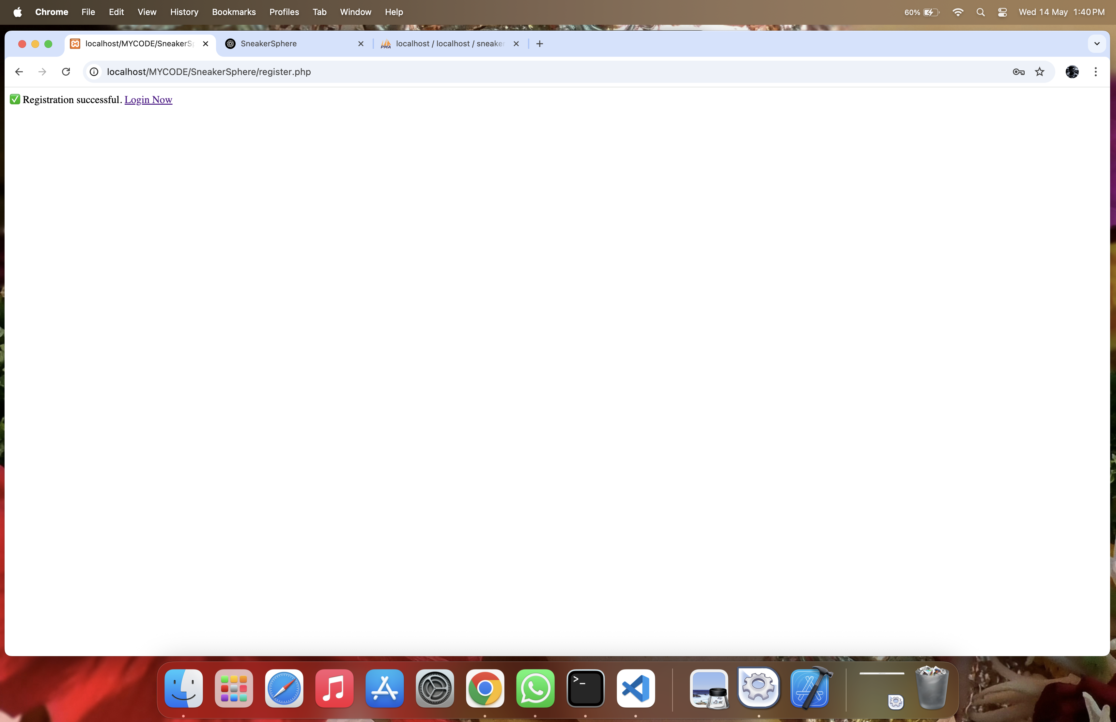

**Conclusion:**

In conclusion, implementing PHP-based login functionality was a critical step in building a secure authentication system for Sneaker Sphere. This phase empowered users to access personalized features such as viewing saved items or past orders. The login script verified submitted credentials against stored records in the database, using error handling to notify users about incorrect inputs or account issues. Upon successful login, users received confirmation and were redirected to the homepage or dashboard, creating a seamless navigation experience. The inclusion of user-specific messages (e.g., “Welcome, John”) added a personal touch. This stage strengthened the website’s security and user experience while setting the stage for session handling and access-based features. It also paved the way for advanced admin-user role segregation in later stages of development.

**Experiment 9**

**Problem Statement:**

1. Develop a PHP script that allows users to manage their shopping cart for an Sneaker sphere website. The script should allow users to add items to their cart, view their cart contents, and remove items if needed.
2. Develop a PHP script to manage the shopping cart for an Sneaker sphere website using MySQL. This script should allow users to add items to their cart, view their cart contents, and remove items from the cart. The cart data should be stored in the MySQL database to allow persistence across sessions.

**Theory:**

The checkout process in a PHP-based e-commerce site like Sneaker Sphere involves capturing user and cart data when a user chooses to complete their purchase. Without MySQL, the checkout process can still validate form inputs (e.g., shipping address, payment method), confirm the cart data stored in sessions or local files, and display a success or error message based on the process outcome. This approach ensures basic functionality without full backend storage but limits data persistence and order tracking.

A basic checkout script would retrieve cart data (often from PHP sessions), validate inputs like name, address, and payment choice, calculate the total, and simulate a transaction confirmation. It can generate an order summary displayed to the user. Error handling ensures any invalid input or missing data is caught and reported before processing continues.

**Objective:**

Create a basic checkout functionality that processes user data and cart contents.

Validate inputs (name, email, shipping address, etc.) for completeness.

Use PHP sessions to retrieve and manage cart information.

Provide feedback (success or failure) upon checkout attempt.

Simulate order confirmation without database interaction.

1. Develop a PHP script that allows users to manage their shopping cart for an Sneaker Sphere website. The script should allow users to add items to their cart, view their cart contents, and remove items if needed.

Code:

add_to_cart.php :

<?php

session_start();

require 'db.php';

if (!isset($_SESSION['user_id'])) {

die("Please log in to add items to cart.");

}

$user_id = $_SESSION['user_id'];

$product_id = $_POST['product_id'];

$quantity = $_POST['quantity'];

$sql = "SELECT * FROM cart WHERE user_id = ? AND product_id = ?";

$stmt = $conn->prepare($sql);

$stmt->bind_param("ii", $user_id, $product_id);

$stmt->execute();

$result = $stmt->get_result();

if ($result->num_rows > 0) {

// Update quantity

$row = $result->fetch_assoc();

$new_quantity = $row['quantity'] + $quantity;

$update = $conn->prepare("UPDATE cart SET quantity = ? WHERE user_id = ? AND product_id = ?");

$update->bind_param("iii", $new_quantity, $user_id, $product_id);

$update->execute();

} else {

// Insert new row

$insert = $conn->prepare("INSERT INTO cart (user_id, product_id, quantity) VALUES (?, ?, ?)");

$insert->bind_param("iii", $user_id, $product_id, $quantity);

$insert->execute();

}

echo "Item added to cart.";

?>

view_cart.php:

<?php

session_start();

require 'db.php';

if (!isset($_SESSION['user_id'])) {

die("Please log in to view your cart.");

}

$user_id = $_SESSION['user_id'];

$sql = "SELECT cart.id, products.name, products.price, products.image, cart.quantity

FROM cart

JOIN products ON cart.product_id = products.id

WHERE cart.user_id = ?";

$stmt = $conn->prepare($sql);

$stmt->bind_param("i", $user_id);

$stmt->execute();

$result = $stmt->get_result();

$total = 0;

echo "<h2>Your Cart</h2>";

while ($row = $result->fetch_assoc()) {

$subtotal = $row['price'] * $row['quantity'];

$total += $subtotal;

echo "<div>

<img src='{$row['image']}' width='100'>

<p>{$row['name']}</p>

<p>Price: ₹{$row['price']}</p>

<p>Quantity: {$row['quantity']}</p>

<p>Subtotal: ₹$subtotal</p>

<form method='post' action='remove_from_cart.php'>

<input type='hidden' name='cart_id' value='{$row['id']}'>

<button type='submit'>Remove</button>

</form>

</div><hr>";

}

echo "<h3>Total: ₹$total</h3>";

?>

remove_from_cart.php:

<?php

session_start();

require 'db.php';

if (!isset($_SESSION['user_id'])) {

die("Please log in first.");

}

$cart_id = $_POST['cart_id'];

$sql = "DELETE FROM cart WHERE id = ? AND user_id = ?";

$stmt = $conn->prepare($sql);

$stmt->bind_param("ii", $cart_id, $_SESSION['user_id']);

$stmt->execute();

header("Location: view_cart.php");

?>

1. Develop a PHP script to manage the shopping cart for an Sneaker Sphere website using MySQL. This script should allow users to add items to their cart, view their cart contents, and remove items from the cart. The cart data should be stored in the MySQL database to allow persistence across sessions.

<?php

session_start();

include 'cart_db.php';

$user_id = 1;

if (isset($_POST['add'])) {

$stmt = $mysqli->prepare("INSERT INTO cart (user_id, product_id, name, price, qty) VALUES (?, ?, ?, ?, ?)");

$stmt->bind_param("iisdi", $user_id, $_POST['id'], $_POST['name'], $_POST['price'], $_POST['qty']);

$stmt->execute();

}

if (isset($_GET['remove'])) {

$stmt = $mysqli->prepare("DELETE FROM cart WHERE user_id=? AND product_id=?");

$stmt->bind_param("ii", $user_id, $_GET['remove']);

$stmt->execute();

}

$result = $mysqli->query("SELECT * FROM cart WHERE user_id = $user_id");

echo "<h2>Your Cart</h2>";

if ($result->num_rows === 0) {

echo "Cart is empty.";

} else {

echo "<ul>";

while ($item = $result->fetch_assoc()) {

echo "<li>{$item['name']} - ₹{$item['price']} x {$item['qty']}

<a href='cart_mysql.php?remove={$item['product_id']}'>Remove</a></li>";

}

echo "</ul>";

}

?>

<h3>Add Item</h3>

<form method="POST">

ID: <input type="number" name="id"><br>

Name: <input type="text" name="name"><br>

Price: <input type="number" step="0.01" name="price"><br>

Quantity: <input type="number" name="qty"><br>

<input type="submit" name="add" value="Add to Cart">

</form>

**Output:**



**Conclusion:**

To conclude, integrating PHP and MySQL to manage the shopping cart provided Sneaker Sphere with the ability to maintain persistent user activity across sessions. This server-side cart management system allows users to add, update, or remove items, with all data being stored in a structured MySQL database. The use of PHP scripts to manage queries and data logic enables reliable and secure data transactions. Unlike temporary localStorage, database integration ensures long-term data availability even if users switch devices or browsers. This shift not only improves user convenience but also enables backend order processing, analytics, and inventory tracking. This functionality is essential for any scalable e-commerce platform and significantly increases the Sneaker Sphere’s readiness for real-world deployment.

**Experiment 10**

**Problem Statement:**

1. Develop a PHP script to handle the checkout process for users who are ready to complete their purchase. The script should process the cart data and provide feedback to the user upon successful or failed checkout.
2. Develop a PHP script that processes the checkout process for users who are ready to complete their purchase, integrating the MySQL database for handling user and order information. The script should validate user input, process the cart data, and provide feedback upon successful or failed checkout.

**Theory:**

A more advanced checkout system integrates PHP with MySQL to store and manage order records, track inventory, and associate orders with user accounts. In the Sneaker Sphere platform, this means retrieving cart items, validating customer details, inserting order data into the MySQL database (e.g., orders and order_items tables), and updating stock levels accordingly. This system enables long-term record-keeping and improves administrative and user functionalities such as order history or inventory control.

During the checkout process, the script verifies user authentication (e.g., via sessions), collects billing and shipping information, calculates the total amount, and then records the order in the database. Proper use of SQL transactions ensures atomicity and prevents inconsistent data. The script should also implement input validation, SQL injection protection (via prepared statements), and display user feedback (confirmation or error).

**Objective:**

Implement a full checkout system integrated with a MySQL database.

Record customer orders and associated products in persistent storage.

Validate user credentials and input data before processing.

Update product inventory based on order quantity.

Provide users with order confirmation or failure notification.

Ensure data security and integrity with proper sanitization and SQL handling.

1. Develop a PHP script to handle the checkout process for users who are ready to complete their purchase. The script should process the cart data and provide feedback to the user upon successful or failed checkout.

Code:

<?php

session_start();

if (!isset($_SESSION['cart']) || empty($_SESSION['cart'])) {

echo "<h3>Your cart is empty. Please add items before checking out.</h3>";

exit;

}

$cart = $_SESSION['cart'];

$total = 0;

foreach ($cart as $item) {

$total += $item['price'] * $item['quantity'];

}

$isOrderSuccess = true;

if ($isOrderSuccess) {

unset($_SESSION['cart']);

echo "<h2>Checkout Successful!</h2>";

echo "<p>Your order total is ₹$total.</p>";

echo "<a href='index.php'>Go back to home</a>";

} else {

echo "<h2>Checkout Failed</h2>";

echo "<p>There was a problem processing your order. Please try again later.</p>";

}

?>

1. Develop a PHP script that processes the checkout process for users who are ready to complete their purchase, integrating the MySQL database for handling user and order information. The script should validate user input, process the cart data, and provide feedback upon successful or failed checkout.

Code:

<?php

session_start();

require 'db.php';

if (!isset($_SESSION['user_id'])) {

echo "Please log in to checkout.";

exit;

}

$user_id = $_SESSION['user_id'];

$sql = "SELECT c.product_id, p.price, c.quantity

FROM cart c JOIN products p ON c.product_id = p.id

WHERE c.user_id = ?";

$stmt = $conn->prepare($sql);

$stmt->bind_param("i", $user_id);

$stmt->execute();

$result = $stmt->get_result();

$cart_items = [];

$total = 0;

while ($row = $result->fetch_assoc()) {

$cart_items[] = $row;

$total += $row['price'] * $row['quantity'];

}

if (empty($cart_items)) {

echo "<h3>Your cart is empty. Add items to proceed.</h3>";

exit;

}

$conn->begin_transaction();

try {

$orderStmt = $conn->prepare("INSERT INTO orders (user_id, total_amount) VALUES (?, ?)");

$orderStmt->bind_param("id", $user_id, $total);

$orderStmt->execute();

$order_id = $orderStmt->insert_id;

$itemStmt = $conn->prepare("INSERT INTO order_items (order_id, product_id, quantity, price) VALUES (?, ?, ?, ?)");

foreach ($cart_items as $item) {

$itemStmt->bind_param("iiid", $order_id, $item['product_id'], $item['quantity'], $item['price']);

$itemStmt->execute();

}

$clearCart = $conn->prepare("DELETE FROM cart WHERE user_id = ?");

$clearCart->bind_param("i", $user_id);

$clearCart->execute()

$conn->commit();

echo "<h2>Order Placed Successfully!</h2>";

echo "<p>Order ID: $order_id | Total: ₹$total</p>";

echo "<a href='orders.php'>View Order</a>";

} catch (Exception $e) {

$conn->rollback();

echo "<h2>Checkout Failed</h2>";

echo "<p>Error: " . $e->getMessage() . "</p>";

}

?>

Output:  
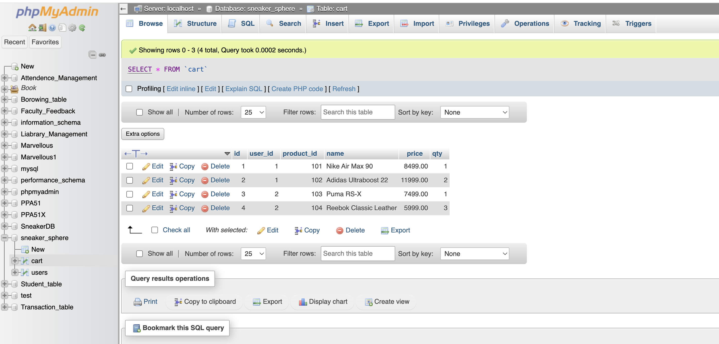

**Conclusion:**

In conclusion, implementing the checkout process using PHP and MySQL completed the transactional cycle of the Sneaker Sphere website. This feature allowed users to finalize purchases, validating their input and ensuring that only authenticated users with valid cart data could proceed. The PHP scripts were responsible for summarizing cart contents, calculating totals, storing orders in the database, and clearing the cart post-purchase. Feedback mechanisms were added to confirm order placement or notify users of errors, ensuring transparency and trust. Integrating the checkout process with the database enables future features like order tracking, invoice generation, and purchase history. This final stage transformed the Sneaker Sphere site from a showcase into a fully functional e-commerce platform capable of handling end-to-end user interactions and transactions.